**ELECTRONIC SUPPLEMENTARY MATERIAL**

**Table S1.** Median, trimmed mean, MAD and trimmed SD of misorientation angles calculated by *PPCA* and *P*min *T* in the validation period of each station in GHBSN with the number of events in each validation period.

|  |  |  |  |  |  |  |  |  |  |  |  |  |  |  |  |  |  |  |  |
| --- | --- | --- | --- | --- | --- | --- | --- | --- | --- | --- | --- | --- | --- | --- | --- | --- | --- | --- | --- |
| Station | | Start | | End | | Median  (PCA) | | MAD  (PCA) | | Mean  (PCA) | | SD  (PCA) | | Median  (min *T*) | MAD  (min *T*) | Mean  (min *T*) | SD  (min *T*) | Events  (PCA) | Events  (min *T*) |
| N001 | | 2018–06–12 | | 2019–11–23 | | –1.35 | | 3.26 | | –1.73 | | 5.08 | | 65 | –1.46 | 3.43 | –1.45 | 4.88 | 72 |
| N001 | | 2020–09–17 | | 2021–03–04 | | –2.47 | | 2.43 | | –2.27 | | 3.64 | 22 | –3.38 | 2.46 | –2.41 | 3.22 | 21 |
| N002 | | 2018–06–12 | | 2019–11–23 | | 5.41 | | 3.2 | | 4.88 | | 5.14 | 47 | 5 | 3.72 | 5.33 | 5.93 | 47 |
| N002 | | 2020–08–18 | | 2021–03–04 | | –15.94 | | 4.38 | | –16.3 | | 5.37 | 18 | –15.43 | 4.66 | –15.43 | 6 | 18 |
| N003 | | 2018–05–17 | | 2019–11–24 | | 22.76 | | 3.06 | | 22.17 | | 4.35 | 67 | 21.88 | 2.77 | 22.11 | 4.19 | 69 |
| N003 | | 2020–08–18 | | 2021–03–04 | | 1.65 | | 1.88 | | 2.37 | | 3.03 | 21 | 1.84 | 2.13 | 2.54 | 3.5 | 21 |
| N004 | | 2018–06–02 | | 2019–11–24 | | –0.97 | | 2.43 | | –0.82 | | 4.2 | 61 | –1.09 | 2.2 | –0.78 | 3.5 | 65 |
| N004 | | 2020–08–18 | | 2021–03–04 | | –0.24 | | 2.33 | | 0.14 | | 3.14 | 16 | –1.52 | 2.83 | –1.21 | 4.62 | 15 |
| N005 | | 2018–08–05 | | 2019–11–24 | | –2.14 | | 4.58 | | –2.56 | | 7.44 | 30 | –2.19 | 4.63 | –0.52 | 5.6 | 30 |
| N006 | | 2018–06–12 | | 2019–11–24 | | –22 | | 2.78 | | –21.17 | | 4.36 | 67 | –22.28 | 2.69 | –21.88 | 4.15 | 65 |
| N006 | | 2020–08–18 | | 2021–03–04 | | –1.39 | | 1.63 | | –1.24 | | 3.29 | 24 | –1.8 | 2.79 | –1.65 | 4.11 | 26 |
| N007 | | 2018–06–12 | | 2019–11–24 | | 21.94 | | 4.26 | | 22.5 | | 6.33 | 32 | 21.35 | 4.65 | 20.94 | 7.48 | 35 |
| N007 | | 2020–09–12 | | 2021–03–04 | | –2.27 | | 3.27 | | –3.62 | | 5.67 | 14 | –2.56 | 2.32 | –1.99 | 4.53 | 12 |
| N008 | | 2019–02–21 | | 2019–12–10 | | 19.54 | | 4.19 | | 19.7 | | 6.12 | 39 | 18.85 | 4.65 | 19.16 | 5.89 | 45 |
| N008 | | 2020–02–13 | | 2021–03–04 | | 8.44 | | 3.3 | | 9.03 | | 5.35 | 40 | 7.63 | 4.25 | 8.43 | 6.43 | 45 |
| N009 | | 2019–02–21 | | 2019–09–29 | | –7.13 | | 2.03 | | –7.64 | | 3 | 45 | –7.29 | 1.54 | –7.3 | 2.78 | 43 |
| N009 | | 2019–11–08 | | 2021–03–04 | | 19.34 | | 1.94 | | 18.81 | | 3.6 | 73 | 19.22 | 1.92 | 18.91 | 3.13 | 76 |
| N010 | | 2019–02–21 | | 2019–11–08 | | –16.93 | | 2.53 | | –17.31 | | 3.65 | 59 | –16.95 | 2.17 | –16.57 | 3.33 | 59 |
| N010 | | 2019–11–14 | | 2021–03–04 | | –6.1 | | 2.37 | | –6.36 | | 3.73 | 80 | –6.67 | 2.31 | –6.86 | 3.88 | 83 |
| N011 | | 2019–02–21 | | 2019–11–08 | | –2.69 | | 2.7 | | –2.32 | | 4.75 | 57 | –1.84 | 2.56 | –2.61 | 4.24 | 60 |
| N011 | | 2019–11–14 | | 2021–03–04 | | 10.91 | | 2.78 | | 10.02 | | 3.78 | 83 | 10.46 | 3.09 | 10.19 | 3.8 | 85 |
| N012 | | 2019–03–04 | | 2019–10–31 | | 9.51 | | 2.76 | | 10.35 | | 4.07 | 56 | 10.35 | 2.93 | 10.48 | 4.42 | 57 |
| N012 | | 2019–11–14 | | 2020–03–25 | | –19.48 | | 3.31 | | –19.39 | | 3.46 | 13 | –20.38 | 3.83 | –20.02 | 4.04 | 16 |
| N012 | | 2020–04–10 | | 2021–03–04 | | 28.78 | | 3.13 | | 28.59 | | 4.57 | 68 | 29.27 | 2.75 | 29.11 | 4.35 | 68 |
| N013 | | 2019–03–06 | | 2019–12–16 | | 1.84 | | 2.26 | | 1.78 | | 3.67 | 55 | 1.63 | 1.91 | 2 | 3.28 | 57 |
| N013 | | 2020–01–02 | | 2021–03–04 | | –5.45 | | 3.39 | | –5.69 | | 4.3 | 64 | –5.22 | 3.06 | –5.78 | 4.42 | 71 |
| N014 | | 2019–02–21 | | 2019–10–31 | | –17.81 | | 1.8 | | –18.03 | | 2.54 | 32 | –17 | 2.02 | –17.59 | 2.74 | 37 |
| N014 | | 2019–11–08 | | 2021–03–04 | | –1.19 | | 4.17 | | –2.11 | | 5.47 | 53 | –1.65 | 3.78 | –2.16 | 5.43 | 53 |
| N015 | | 2019–02–21 | | 2019–12–10 | | 0.7 | | 2.44 | | 0.17 | | 3.48 | 50 | 0.37 | 2.22 | 0.09 | 3.54 | 55 |
| N015 | | 2020–01–02 | | 2021–03–04 | | 7.31 | | 2.05 | | 7 | | 4.18 | 64 | 7.08 | 2.3 | 6.82 | 4 | 62 |
| N016 | | 2019–02–21 | | 2019–11–14 | | –2.2 | | 3.03 | | –2.77 | | 5.13 | 53 | –1.61 | 2.62 | –1.97 | 4.51 | 56 |
| N016 | | 2019–11–23 | | 2021–03–04 | | 4.05 | | 2.24 | | 3.6 | | 3.69 | 81 | 4.09 | 2.24 | 3.92 | 3.85 | 75 |
| N017 | | 2019–02–21 | | 2021–03–04 | | –5.51 | | 2.76 | | –5.74 | | 3.65 | 146 | –5.61 | 2.9 | –5.92 | 3.98 | 152 |
| N018 | | 2019–03–06 | | 2019–11–04 | | 6.03 | | 2.37 | | 6.04 | | 3.59 | 39 | 7 | 2.66 | 6.44 | 3.72 | 40 |
| N018 | | 2019–11–08 | | 2021–03–04 | | –2.15 | | 3.32 | | –1.68 | | 5.38 | 88 | –2.2 | 3.06 | –2.54 | 4.91 | 88 |
| N019 | | 2019–02–21 | | 2019–12–15 | | 1.7 | | 3.17 | | 1.13 | | 4.51 | 73 | 1.92 | 2.34 | 1.62 | 4.08 | 67 |
| N019 | | 2020–01–02 | | 2021–03–04 | | 7.01 | | 2.2 | | 7.13 | | 3.28 | 77 | 6.94 | 2.47 | 7.17 | 3.81 | 75 |
| N020 | | 2019–02–02 | | 2019–03–06 | | –24.86 | | 1.67 | | –24.22 | | 3.34 | 6 | –22.95 | 2.14 | –23.55 | 2.77 | 6 |
| N020 | | 2019–03–08 | | 2019–12–15 | | –2.77 | | 2.28 | | –3.3 | | 3.87 | 64 | –1.93 | 2.07 | –2.85 | 3.64 | 63 |
| N020 | | 2020–01–02 | | 2021–03–04 | | –18.85 | | 2.68 | | –18.85 | | 3.73 | 81 | –18.65 | 2.51 | –18.58 | 3.79 | 82 |
| N021 | | 2019–03–02 | | 2019–11–24 | | 3.15 | | 2.37 | | 3.21 | | 3.55 | 44 | 3.57 | 1.9 | 3.47 | 3.49 | 47 |
| N021 | | 2019–12–10 | | 2021–03–04 | | –5.19 | | 2.52 | | –5.83 | | 3.66 | 55 | –5.3 | 2.45 | –5.63 | 3.79 | 61 |
| N022 | | 2019–02–21 | | 2019–12–15 | | 22.91 | | 2.03 | | 22.68 | | 3.69 | 70 | 22.73 | 2.47 | 22.43 | 3.97 | 76 |
| N022 | | 2020–01–02 | | 2021–03–04 | | 36.9 | | 2.69 | | 36.83 | | 3.46 | 70 | 36.51 | 2.32 | 36.02 | 3.54 | 75 |
| N023 | | 2019–03–06 | | 2019–10–31 | | 7.92 | | 3.48 | | 7.88 | | 4.4 | 51 | 8.08 | 2.81 | 8.18 | 3.89 | 54 |
| N023 | | 2019–11–08 | | 2021–03–04 | | –14.28 | | 2.54 | | –14.61 | | 3.65 | 83 | –14.6 | 2.41 | –14.65 | 3.4 | 81 |
| N024 | | 2019–03–08 | | 2019–11–14 | | 1.79 | | 2.36 | | 1.77 | | 3.96 | 51 | 1.32 | 2.26 | 1.54 | 3.83 | 53 |
| N024 | | 2019–11–23 | | 2021–03–04 | | –2.13 | | 2.1 | | –2.11 | | 3.12 | 76 | –2.4 | 2.33 | –2.03 | 3.81 | 75 |
| N025 | | 2019–02–21 | | 2019–10–31 | | –2.49 | | 3.52 | | –3.04 | | 5.73 | 33 | –2.73 | 3.03 | –2.47 | 5.73 | 35 |
| N025 | | 2019–11–08 | | 2021–03–04 | | –33.96 | | 3.2 | | –33.58 | | 4.05 | 52 | –33.5 | 3.16 | –33.44 | 4.14 | 52 |
| N026 | | 2019–02–21 | | 2020–01–19 | | 2.17 | | 3.16 | | 1.84 | | 4.36 | 69 | 2.41 | 2.56 | 2.3 | 3.97 | 67 |
| N026 | | 2020–04–10 | | 2021–03–04 | | 7.14 | | 2.39 | | 7.44 | | 3.65 | 63 | 7.67 | 2.42 | 7.5 | 3.41 | 69 |
| N027 | | 2019–02–21 | | 2019–12–15 | | –4.48 | | 2.82 | | –4.29 | | 4.4 | 83 | –3.43 | 2.53 | –3.69 | 3.84 | 76 |
| N027 | | 2020–01–02 | | 2021–03–04 | | 1.2 | | 2.41 | | 1.1 | | 3.8 | 88 | 1.34 | 2.64 | 1.05 | 4.43 | 88 |
| N028 | | 2019–02–02 | | 2021–03–04 | | 4.77 | | 3.08 | | 5.09 | | 4.5 | 156 | 5.69 | 3.14 | 5.42 | 4.56 | 157 |
| N029 | | 2019–03–08 | | 2019–10–31 | | –2.89 | | 2.99 | | –2.2 | | 4.37 | 35 | –1.03 | 2.9 | –2.08 | 4.29 | 41 |
| N029 | | 2019–11–14 | | 2021–03–04 | | 14.53 | | 2.48 | | 14.9 | | 3.64 | 62 | 14.93 | 2.58 | 14.76 | 4.36 | 69 |
| N030 | | 2019–02–21 | | 2020–01–26 | | –7.09 | | 4.6 | | –8.73 | | 8 | 75 | –7.15 | 4.39 | –8.38 | 7.7 | 69 |
| N030 | | 2020–02–20 | | 2021–03–04 | | 3.76 | | 13.75 | | 2.62 | | 14.62 | 68 | 4.17 | 12.93 | 3.28 | 13.98 | 67 |
| N031 | | 2019–02–21 | | 2019–10–29 | | 2.26 | | 1.66 | | 1.82 | | 2.49 | 51 | 2.46 | 1.85 | 2 | 3.38 | 56 |
| N031 | | 2019–11–08 | | 2021–03–04 | | –14.53 | | 1.98 | | –14.17 | | 3.26 | 75 | –14.16 | 1.84 | –14.61 | 2.9 | 72 |
| N032 | | 2019–03–20 | | 2019–10–31 | | –1.7 | | 3 | | –2.14 | | 4.33 | 40 | –1.61 | 3.05 | –1.81 | 4.29 | 40 |
| N032 | | 2019–11–14 | | 2021–03–04 | | 9.46 | | 3.53 | | 8.92 | | 4.87 | 56 | 9.2 | 3.13 | 8.93 | 4.81 | 58 |
| N033 | | 2019–03–24 | | 2019–09–27 | | –8.3 | | 4.71 | | –7.95 | | 6.46 | 33 | –8.33 | 4.73 | –9.08 | 6.12 | 33 |
| N033 | | 2020–01–02 | | 2021–03–04 | | 2.52 | | 3.19 | | 2.31 | | 4.82 | 71 | 2.12 | 3.51 | 2.08 | 4.47 | 72 |
| N034 | | 2019–03–06 | | 2019–10–29 | | 21.46 | | 3.98 | | 22.01 | | 6.44 | 43 | 21.64 | 3.48 | 21.32 | 5.07 | 44 |
| N034 | | 2019–11–08 | | 2020–01–07 | | 0.91 | | 5.58 | | –0.85 | | 6.32 | 9 | 0.3 | 6.17 | –1.31 | 7.13 | 9 |
| N034 | | 2020–02–05 | | 2021–03–04 | | 24.85 | | 3.14 | | 24.65 | | 5.37 | 60 | 24.66 | 3.16 | 24.97 | 5.36 | 66 |
| N035 | | 2019–02–21 | | 2020–01–07 | | –18.13 | | 3.53 | | –18.23 | | 4.46 | 35 | –16.98 | 2.83 | –17.72 | 4.9 | 38 |
| N035 | | 2020–01–19 | | 2021–03–04 | | 6.13 | | 2.61 | | 6.06 | | 3.93 | 54 | 6.98 | 2.37 | 6.66 | 3.7 | 58 |
| N036 | | 2020–03–14 | | 2020–06–07 | | –6.87 | | 3.75 | | –6.7 | | 4.86 | 14 | –6.32 | 3.44 | –6.4 | 5.4 | 14 |
| N036 | | 2020–06–13 | | 2021–03–04 | | 8.41 | | 2.57 | | 8.84 | | 4.09 | 52 | 8.82 | 2.66 | 9.16 | 4.21 | 50 |
| N037 | | 2019–02–21 | | 2019–12–15 | | –7.86 | | 2.38 | | –6.96 | | 3.58 | 55 | –7.34 | 2.17 | –6.8 | 3.14 | 55 |
| N037 | | 2020–01–19 | | 2021–03–04 | | –31.41 | | 2.89 | | –31.37 | | 3.89 | 55 | –31.28 | 2.34 | –31.39 | 3.67 | 58 |
| N038 | | 2019–02–21 | | 2021–03–04 | | –2.54 | | 3.11 | | –2.63 | | 4.46 | 116 | –2.31 | 2.6 | –2.69 | 3.85 | 117 |
| N039 | | 2019–03–10 | | 2019–10–21 | | 7.81 | | 2.39 | | 8.31 | | 3.37 | 47 | 8.23 | 2.31 | 8.49 | 2.87 | 48 |
| N039 | | 2019–11–08 | | 2021–03–04 | | –15.13 | | 2.67 | | –15.29 | | 3.71 | 87 | –15.32 | 2.6 | –15.56 | 3.86 | 85 |
| N040 | | 2019–02–02 | | 2019–03–06 | | –23.53 | | 1.95 | | –23.58 | | 2.91 | 6 | –23.93 | 2.21 | –23.59 | 3.48 | 5 |
| N040 | | 2019–03–08 | | 2019–12–10 | | –2.54 | | 2.57 | | –2.54 | | 3.64 | 60 | –2.59 | 2.36 | –2.45 | 3.36 | 60 |
| N040 | | 2020–01–07 | | 2021–03–04 | | 8.82 | | 2.18 | | 8.69 | | 3.29 | 70 | 8.04 | 2.34 | 7.8 | 4.13 | 71 |
| N041 | | 2019–03–06 | | 2019–12–15 | | –0.22 | | 3.31 | | –0.57 | | 4.56 | 38 | –0.25 | 3.33 | –0.81 | 4.33 | 36 |
| N041 | | 2020–01–02 | | 2021–03–04 | | 5.15 | | 3.68 | | 4.96 | | 4.86 | 67 | 4.74 | 3.42 | 5.14 | 4.24 | 69 |
| N042 | | 2019–03–08 | | 2021–03–05 | | –6.67 | | 2.28 | | –6.57 | | 3.56 | 124 | –6.14 | 2.33 | –6.31 | 3.76 | 122 |
| N043 | | 2019–03–08 | | 2019–12–10 | | 3.23 | | 2.01 | | 3.14 | | 2.66 | 44 | 3.85 | 2.79 | 3.23 | 3.94 | 47 |
| N043 | | 2020–01–02 | | 2021–03–04 | | –1.96 | | 2.14 | | –1.93 | | 3.45 | 74 | –2.26 | 2.15 | –2.5 | 3.75 | 79 |
| N044 | | 2019–06–15 | | 2019–11–08 | | 9.76 | | 1.84 | | 9.6 | | 3.55 | 26 | 10.42 | 2.04 | 10.24 | 3.14 | 30 |
| N044 | | 2020–12–10 | | 2021–03–04 | | 4.33 | | 1.64 | | 3.36 | | 2.54 | 11 | 4.46 | 1.94 | 3.63 | 2.81 | 10 |
| N045 | | 2019–03–08 | | 2019–12–10 | | 4.51 | | 2.26 | | 4.14 | | 3.23 | 54 | 4.41 | 2.09 | 3.87 | 3.23 | 52 |
| N045 | | 2020–01–02 | | 2021–03–04 | | –0.27 | | 2.41 | | –0.64 | | 3.43 | 68 | –0.77 | 2.52 | –1.46 | 3.76 | 69 |
| N046 | | 2019–03–08 | | 2019–12–15 | | –1.36 | | 2.7 | | –1.66 | | 3.44 | 57 | –0.69 | 2.27 | –0.96 | 3.25 | 63 |
| N046 | | 2020–01–23 | | 2021–03–04 | | –9.37 | | 2.7 | | –9.44 | | 3.96 | 65 | –9.49 | 2.56 | –9.69 | 3.58 | 66 |
| N047 | | 2019–03–08 | | 2019–12–15 | | –4.11 | | 2.33 | | –4.35 | | 3.38 | 64 | –3.96 | 2.53 | –4.21 | 4.04 | 64 |
| N047 | | 2020–01–02 | | 2021–03–04 | | 2.41 | | 2.69 | | 1.81 | | 3.35 | 72 | 2.62 | 2.73 | 2.38 | 3.55 | 75 |
| N048 | | 2019–03–24 | | 2020–01–02 | | 17.17 | | 5.17 | | 19.05 | | 8.8 | 32 | 17.67 | 4.42 | 17.62 | 7.54 | 34 |
| N048 | | 2020–02–13 | | 2021–03–04 | | 0.61 | | 4.39 | | 0.62 | | 6.3 | 44 | 0.59 | 3.85 | 0.24 | 6.36 | 44 |
| N049 | | 2019–03–20 | | 2019–11–04 | | –6.97 | | 3.14 | | –6.61 | | 5.23 | 43 | –7.4 | 3.43 | –7.56 | 4.99 | 43 |
| N049 | | 2019–11–08 | | 2021–03–04 | | 17.85 | | 3.76 | | 17.28 | | 5.65 | 77 | 17.68 | 4.13 | 16.95 | 5.72 | 75 |
| N050 | | 2019–03–10 | | 2019–11–04 | | –9.12 | | 2.48 | | –8.88 | | 4.11 | 50 | –8.97 | 2.55 | –8.38 | 4.19 | 51 |
| N050 | | 2019–11–08 | | 2021–03–04 | | 8.17 | | 2.46 | | 8.49 | | 4.04 | 82 | 8.02 | 2.65 | 8.14 | 4.06 | 82 |
| N051 | | 2019–03–10 | | 2019–10–21 | | –6.88 | | 2.3 | | –6.31 | | 2.86 | 44 | –7.07 | 2.21 | –6.92 | 3.58 | 44 |
| N051 | | 2019–11–04 | | 2021–03–04 | | 14.32 | | 2.14 | | 13.92 | | 3.93 | 72 | 14.49 | 2.44 | 14.77 | 3.91 | 74 |
| N052 | | 2019–03–02 | | 2020–01–26 | | –27.56 | | 5.66 | | –28.74 | | 7.25 | 52 | –28.12 | 4.72 | –29.43 | 7.28 | 55 |
| N052 | | 2020–02–13 | | 2021–03–04 | | 23.2 | | 2.95 | | 23.17 | | 4.32 | 53 | 23.01 | 3.88 | 23.38 | 5.42 | 62 |
| N053 | | 2019–03–30 | | 2019–10–31 | | –3.93 | | 2.18 | | –4.09 | | 3.64 | 58 | –3.99 | 1.82 | –4.01 | 3.34 | 58 |
| N053 | | 2019–11–08 | | 2021–03–04 | | –13.41 | | 2.3 | | –13.3 | | 3.77 | 83 | –13.96 | 2.45 | –13.94 | 3.76 | 82 |
| N054 | | 2019–03–20 | | 2019–10–31 | | –0.9 | | 2.4 | | –1.05 | | 4.42 | 50 | –0.55 | 2.42 | –0.63 | 3.98 | 53 |
| N054 | | 2019–11–04 | | 2021–03–04 | | –11.52 | | 2.23 | | –11.19 | | 3.34 | 85 | –12 | 2.31 | –11.46 | 3.55 | 87 |
| N055 | | 2019–03–24 | | 2019–10–31 | | –8.76 | | 2.41 | | –9.1 | | 3.54 | 54 | –8.74 | 2.18 | –9.29 | 3.5 | 54 |
| N055 | | 2019–11–08 | | 2021–03–04 | | 5.68 | | 2.51 | | 5.56 | | 4.22 | 90 | 5.95 | 2.38 | 5.84 | 3.52 | 88 |
| N056 | | 2019–03–28 | | 2019–10–29 | | 2.63 | | 2.03 | | 2.79 | | 3.52 | 41 | 3.67 | 2.28 | 3.12 | 3.58 | 45 |
| N056 | | 2019–11–04 | | 2021–03–04 | | –7.14 | | 2.22 | | –7.22 | | 3.67 | 67 | –7.02 | 2.22 | –7.04 | 3.47 | 69 |
| N057 | | 2019–03–20 | | 2021–03–04 | | –8.18 | | 3.11 | | –7.89 | | 4.78 | 147 | –8.3 | 3.04 | –8.38 | 4.55 | 142 |
| N058 | | 2019–03–10 | | 2019–11–26 | | –3.35 | | 2.63 | | –3.06 | | 4.53 | 53 | –2.6 | 2.09 | –2.34 | 3.61 | 52 |
| N058 | | 2019–12–10 | | 2021–03–04 | | 1.63 | | 2.35 | | 1.58 | | 4.05 | 67 | 1.78 | 2.04 | 2.04 | 3.96 | 63 |
| N059 | | 2019–03–24 | | 2019–12–15 | | 4.74 | | 3.61 | | 4.45 | | 6.65 | 57 | 5.34 | 4.27 | 4.66 | 5.54 | 52 |
| N059 | | 2020–01–02 | | 2021–03–04 | | 10.56 | | 3.69 | | 9.79 | | 5.04 | 72 | 10.07 | 2.96 | 9.5 | 4.54 | 67 |
| N060 | | 2019–03–02 | | 2021–03–04 | | 14.07 | | 2.97 | | 13.89 | | 4.6 | 117 | 14.24 | 3.31 | 13.93 | 5.28 | 131 |
| N061 | | 2019–03–02 | | 2020–01–26 | | 7.84 | | 2.98 | | 7.43 | | 4.89 | 80 | 7.91 | 3.04 | 7.35 | 5.02 | 76 |
| N061 | | 2020–02–05 | | 2021–03–04 | | –9.59 | | 2.75 | | –9.68 | | 4.42 | 73 | –9.35 | 3.05 | –9.93 | 5.1 | 75 |
| N062 | | 2019–03–02 | | 2019–11–04 | | 7.81 | | 2.99 | | 7.08 | | 4.27 | 40 | 8.72 | 2.99 | 7.96 | 4.12 | 38 |
| N062 | | 2019–11–08 | | 2021–03–04 | | –2.52 | | 2.8 | | –2.82 | | 3.58 | 51 | –3.6 | 2.57 | –3.62 | 4.36 | 57 |
| N063 | | 2019–03–02 | | 2019–12–15 | | –15.94 | | 2.71 | | –16.29 | | 3.38 | 66 | –15.53 | 2.02 | –15.67 | 3.32 | 65 |
| N063 | | 2020–01–02 | | 2021–03–04 | | 0.5 | | 2.32 | | 0.3 | | 3.36 | 75 | 0.21 | 2.19 | –0.01 | 3.3 | 77 |
| N064 | | 2019–03–28 | | 2019–05–09 | | –13.06 | | 3.45 | | –13.14 | | 3.93 | 13 | –11.66 | 2.12 | –11.76 | 3.52 | 12 |
| N064 | | 2019–07–26 | | 2019–12–15 | | –11.92 | | 2.28 | | –11.28 | | 3.59 | 26 | –10.86 | 2.24 | –11.1 | 3.56 | 25 |
| N064 | | 2020–01–02 | | 2021–03–04 | | 12.29 | | 2.98 | | 11.98 | | 4.28 | 76 | 12.1 | 2.99 | 11.8 | 4.29 | 77 |
| N065 | | 2019–03–02 | | 2019–11–04 | | –18.03 | | 2.04 | | –17.91 | | 3.35 | 33 | –18.04 | 3.65 | –18.18 | 5.8 | 39 |
| N065 | | 2019–11–08 | | 2020–01–19 | | 5.81 | | 3.47 | | 4.22 | | 5.59 | 9 | 2.37 | 4.84 | 1.74 | 5.56 | 8 |
| N065 | | 2020–03–14 | | 2021–03–04 | | –20.8 | | 3.33 | | –21.28 | | 4.43 | 54 | –20.96 | 3.49 | –21.11 | 4.73 | 52 |
| N066 | | 2019–03–24 | | 2020–01–07 | | –10.16 | | 3.26 | | –10.27 | | 4.59 | 53 | –10.12 | 2.46 | –10.45 | 4.37 | 54 |
| N066 | | 2020–02–13 | | 2021–03–04 | | 5.49 | | 2.68 | | 5.97 | | 4.14 | 65 | 5.55 | 2.52 | 5.56 | 4.16 | 66 |
| N067 | | 2019–03–28 | | 2021–03–04 | | 0.43 | | 2.45 | | –0.02 | | 3.94 | 83 | 0.94 | 2.58 | 0.65 | 4.28 | 82 |
| N068 | | 2019–03–24 | | 2019–11–26 | | 11.49 | | 3.34 | | 10.92 | | 4.82 | 54 | 11.81 | 2.94 | 11.61 | 4.61 | 55 |
| N068 | | 2019–12–10 | | 2021–03–04 | | 5.06 | | 3.29 | | 4.36 | | 4.31 | 73 | 4.4 | 2.91 | 3.67 | 4.08 | 76 |
| N069 | | 2019–03–06 | | 2019–12–15 | | –13.31 | | 2.23 | | –13.3 | | 3.01 | 55 | –12.93 | 2.11 | –13.03 | 3.16 | 59 |
| N069 | | 2020–01–02 | | 2021–03–04 | | –1.47 | | 1.94 | | –1.15 | | 2.7 | 66 | –1.39 | 1.82 | –1.39 | 2.93 | 67 |
| N070 | | 2019–03–24 | | 2021–03–04 | | –0.47 | | 2.93 | | –0.18 | | 4.42 | 142 | 0.03 | 3.06 | 0.07 | 4.73 | 139 |
| N071 | | 2019–03–02 | | 2019–11–04 | | –6.78 | | 2.37 | | –7.22 | | 3.52 | 40 | –7.62 | 2.09 | –7.64 | 3.37 | 34 |
| N071 | | 2019–11–08 | | 2021–03–04 | | –22.67 | | 2.84 | | –23.33 | | 4.16 | 78 | –22.6 | 2.09 | –23.5 | 3.68 | 76 |
| N072 | | 2019–03–02 | | 2020–01–26 | | 21.63 | | 2.23 | | 21.38 | | 4.38 | 66 | 22.01 | 2.49 | 21.53 | 4.07 | 72 |
| N072 | | 2020–02–05 | | 2021–03–04 | | 8.44 | | 1.92 | | 8.05 | | 3.26 | 65 | 8.07 | 2.35 | 7.86 | 3.48 | 67 |
| N073 | | 2019–03–24 | | 2019–12–10 | | 3.04 | | 2.32 | | 2.71 | | 3.16 | 57 | 3.29 | 2.67 | 3.48 | 3.57 | 59 |
| N073 | | 2020–01–02 | | 2021–03–04 | | –4.4 | | 2.83 | | –4.76 | | 4.34 | 74 | –4.75 | 2.88 | –5.39 | 4.76 | 73 |
| N074 | | 2019–03–28 | | 2019–12–10 | | 6.64 | | 2.09 | | 7.99 | | 3.64 | 41 | 7.72 | 2.17 | 8.13 | 3.79 | 40 |
| N074 | | 2020–01–07 | | 2021–03–04 | | 14.86 | | 2.75 | | 14.41 | | 5.13 | 58 | 15 | 2.66 | 14.34 | 4.96 | 54 |
| N075 | | 2019–03–20 | | 2019–12–15 | | –7.06 | | 2.58 | | –6.8 | | 3.28 | 69 | –6.48 | 2 | –6.82 | 3.12 | 62 |
| N075 | | 2020–01–02 | | 2021–03–04 | | –0.06 | | 2.03 | | –0.1 | | 3.46 | 78 | 0.21 | 2.33 | –0.53 | 4 | 77 |
| N076 | | 2019–03–02 | | 2019–12–15 | | 3.54 | | 2.58 | | 2.55 | | 4.83 | 60 | 2.86 | 3.43 | 2.7 | 5.01 | 60 |
| N076 | | 2020–02–13 | | 2021–03–04 | | 23.42 | | 3.5 | | 23.31 | | 4.33 | 63 | 22.91 | 3.62 | 22.82 | 4.99 | 71 |
| N077 | | 2019–03–06 | | 2020–02–05 | | 30.52 | | 3.57 | | 29.87 | | 6.28 | 65 | 29.99 | 2.51 | 29.08 | 5.07 | 70 |
| N077 | | 2020–02–13 | | 2021–03–04 | | 16.13 | | 4.83 | | 16.34 | | 5.37 | 66 | 17.12 | 4.57 | 16.54 | 5.38 | 71 |
| N078 | | 2019–03–06 | | 2019–10–16 | | –4.68 | | 3.72 | | –3.16 | | 5.52 | 36 | –2.76 | 3.49 | –2.63 | 5.89 | 36 |
| N078 | | 2019–11–08 | | 2021–03–04 | | –9.44 | | 4 | | –9.01 | | 6.33 | 54 | –10.59 | 4.02 | –10.43 | 6.21 | 55 |
| N079 | | 2019–03–02 | | 2020–01–19 | | 1.06 | | 6.44 | | 0.41 | | 8.8 | 40 | –1.59 | 5.2 | –1.09 | 7.16 | 35 |
| N079 | | 2020–02–13 | | 2021–03–04 | | –11.76 | | 4.02 | | –11.79 | | 5.6 | 48 | –11.85 | 3.43 | –12.47 | 5.17 | 48 |
| N080 | | 2019–03–02 | | 2019–10–31 | | 3.44 | | 2.13 | | 3.57 | | 3.41 | 60 | 3.76 | 2.48 | 3.39 | 3.57 | 61 |
| N080 | | 2019–11–08 | | 2021–03–04 | | –2.09 | | 3.33 | | –2.41 | | 5.08 | 87 | –2.68 | 3.51 | –3.05 | 4.62 | 88 |
| N081 | | 2019–03–02 | | 2021–03–04 | | 3.53 | | 3.61 | | 2.81 | | 6.35 | 128 | 2.77 | 3.39 | 1.79 | 6.2 | 132 |
| N082 | | 2019–03–28 | | 2019–11–04 | | –8.67 | | 2.45 | | –7.83 | | 4.12 | 39 | –8.26 | 2.61 | –8.26 | 4.14 | 35 |
| N082 | | 2020–01–19 | | 2021–03–04 | | 10.27 | | 2.47 | | 11.13 | | 3.91 | 49 | 10.97 | 2.47 | 10.8 | 4.71 | 59 |
| N083 | | 2019–03–02 | | 2019–10–31 | | –37.45 | | 2.34 | | –37.82 | | 3.36 | 56 | –37.39 | 2.58 | –37.89 | 3.83 | 58 |
| N083 | | 2019–11–08 | | 2021–03–04 | | –2.49 | | 2.93 | | –2.52 | | 4.04 | 80 | –2.89 | 2.85 | –3.24 | 4.28 | 83 |
| N084 | | 2019–03–02 | | 2019–10–29 | | –12.82 | | 2.78 | | –12.94 | | 3.72 | 53 | –12.69 | 2.56 | –12.97 | 3.27 | 53 |
| N084 | | 2019–11–08 | | 2021–03–04 | | –66.99 | | 2.99 | | –66.96 | | 4.65 | 77 | –67.34 | 2.29 | –67.45 | 3.84 | 73 |
| N085 | | 2020–02–05 | | 2021–03–04 | | 0.96 | | 1.96 | | 1.41 | | 3.07 | 63 | 1.04 | 2.68 | 0.63 | 3.8 | 67 |
| N086 | | 2019–03–20 | | 2020–01–26 | | 9.59 | | 16.79 | | 10.08 | | 22.04 | 58 | 10.66 | 17.22 | 10.89 | 21.52 | 61 |
| N086 | | 2020–02–05 | | 2021–03–04 | | –13.14 | | 2.26 | | –12.7 | | 3.53 | 69 | –13.31 | 2.33 | –13.5 | 3.41 | 68 |
| N087 | | 2019–03–02 | | 2019–10–21 | | 10.06 | | 4.79 | | 11.1 | | 6.34 | 38 | 9.7 | 3.74 | 10.17 | 6.14 | 42 |
| N087 | | 2019–11–08 | | 2021–03–04 | | –9.52 | | 2.89 | | –10.28 | | 4.97 | 63 | –9.91 | 3.36 | –10.32 | 5.65 | 64 |
| N088 | | 2019–03–20 | | 2021–03–04 | | –6.52 | | 2.5 | | –6.43 | | 3.89 | 124 | –6.14 | 2.02 | –5.95 | 3.23 | 125 |
| N089 | | 2019–03–20 | | 2019–10–31 | | –7.2 | | 2.63 | | –6.97 | | 4.57 | 51 | –6.88 | 2.87 | –6.7 | 4.83 | 49 |
| N089 | | 2019–11–08 | | 2021–03–04 | | 30.07 | | 2.42 | | 30.19 | | 3.23 | 75 | 30.15 | 2.12 | 30.38 | 2.81 | 72 |
| N090 | | 2019–03–02 | | 2019–03–10 | | 7.35 | | 1.85 | | 8.48 | | 2.87 | 7 | 7.27 | 0.78 | 6.77 | 1.07 | 6 |
| N090 | | 2019–03–24 | | 2019–06–19 | | –4.34 | | 3.29 | | –4.41 | | 4.05 | 29 | –5.23 | 1.93 | –4.7 | 3.48 | 26 |
| N090 | | 2019–06–21 | | 2019–12–10 | | 10.47 | | 2.02 | | 11 | | 2.58 | 29 | 11.57 | 1.82 | 11.65 | 2.76 | 33 |
| N090 | | 2020–01–02 | | 2021–03–04 | | 1.31 | | 1.82 | | 1.23 | | 3.19 | 63 | 1.68 | 2.56 | 1.35 | 3.47 | 62 |
| N091 | | 2019–03–02 | | 2020–03–26 | | –15.08 | | 2.48 | | –14.75 | | 4.15 | 77 | –14.8 | 3.27 | –14.33 | 4.66 | 81 |
| N091 | | 2020–04–05 | | 2021–03–04 | | 8.66 | | 2.32 | | 8.44 | | 3.32 | 71 | 8.55 | 2.2 | 8.49 | 3.28 | 70 |
| N092 | | 2019–03–02 | | 2019–06–19 | | 4.83 | | 2.59 | | 5 | | 4.45 | 35 | 5.34 | 2.56 | 5.65 | 3.76 | 33 |
| N092 | | 2019–06–21 | | 2019–10–29 | | –10.17 | | 1.48 | | –10.09 | | 2.3 | 28 | –10.1 | 1.67 | –10.4 | 2.14 | 27 |
| N092 | | 2019–11–08 | | 2021–03–04 | | –14.13 | | 2.64 | | –14.2 | | 4.11 | 90 | –14.34 | 2.56 | –14.36 | 3.65 | 87 |
| N093 | | 2019–03–20 | | 2019–11–04 | | –3.62 | | 2.62 | | –4.01 | | 3.56 | 50 | –4.27 | 2.45 | –4.18 | 3.64 | 46 |
| N093 | | 2019–11–08 | | 2021–03–04 | | 74.77 | | 2.31 | | 75.42 | | 3.62 | 78 | 74.33 | 2.33 | 75.02 | 3.61 | 82 |
| N094 | | 2019–03–28 | | 2019–12–10 | | –8.66 | | 1.98 | | –8.57 | | 3.18 | 53 | –8.09 | 1.94 | –8.2 | 2.91 | 50 |
| N094 | | 2020–01–02 | | 2021–03–04 | | 60.9 | | 2.51 | | 60.81 | | 3.64 | 64 | 60.85 | 2.7 | 60.92 | 4.44 | 64 |
| N095 | | 2019–03–02 | | 2019–12–15 | | –5.53 | | 2.5 | | –5.69 | | 3.45 | 70 | –5.47 | 2.48 | –5.48 | 3.68 | 71 |
| N095 | | 2020–01–02 | | 2021–03–04 | | 18.52 | | 1.81 | | 18.46 | | 2.71 | 63 | 18.08 | 1.9 | 17.93 | 3.04 | 62 |
| N096 | | 2019–03–02 | | 2019–10–31 | | –15.19 | | 2.63 | | –15.24 | | 3.74 | 63 | –15.25 | 2.38 | –14.99 | 3.59 | 61 |
| N096 | | 2019–11–08 | | 2021–03–04 | | 2.53 | | 1.96 | | 2.54 | | 3.25 | 84 | 1.72 | 2.16 | 1.79 | 3.52 | 85 |
| N097 | | 2019–03–20 | | 2019–11–04 | | –2.6 | | 2.64 | | –2.96 | | 3.78 | 56 | –2.97 | 3.23 | –3.12 | 4.11 | 52 |
| N097 | | 2019–11–06 | | 2021–03–04 | | 2 | | 2.43 | | 2.37 | | 3.67 | 86 | 1.83 | 2.49 | 2.33 | 4.04 | 88 |
| N098 | | 2019–03–28 | | 2019–11–04 | | –1.14 | | 2.12 | | –1.21 | | 3.49 | 48 | –0.7 | 2.92 | –0.96 | 4.04 | 48 |
| N098 | | 2019–11–08 | | 2021–03–04 | | 5.55 | | 2.9 | | 5.33 | | 4.66 | 83 | 5.29 | 2.6 | 5.38 | 3.87 | 81 |
| N099 | | 2019–03–02 | | 2019–12–15 | | –22.9 | | 1.96 | | –22.91 | | 3.48 | 69 | –22.52 | 2.09 | –22.43 | 3.46 | 70 |
| N099 | | 2019–12–23 | | 2021–03–04 | | –2.28 | | 2.46 | | –2.79 | | 3.78 | 78 | –2.46 | 2.21 | –2.82 | 2.72 | 74 |
| N100 | | 2019–03–20 | | 2019–07–07 | | 11.96 | | 3.22 | | 11.33 | | 4.45 | 29 | 12.7 | 3.58 | 11.29 | 4.76 | 30 |
| N100 | | 2020–01–07 | | 2021–03–04 | | –6.39 | | 2.79 | | –7.09 | | 4.66 | 56 | –6.05 | 3.66 | –7.11 | 5.25 | 60 |
| N101 | | 2019–03–28 | | 2020–01–07 | | 21.92 | | 5.45 | | 21.18 | | 8.15 | 51 | 21.52 | 4.37 | 20.98 | 7.42 | 51 |
| N101 | | 2020–01–19 | | 2021–02–13 | | 34.48 | | 3.86 | | 34.49 | | 4.83 | 54 | 33.09 | 3.93 | 33.38 | 5.36 | 58 |
| N102 | | 2019–03–28 | | 2019–12–10 | | 0.08 | | 2.72 | | –0.63 | | 4.6 | 52 | –0.51 | 3.71 | –0.91 | 4.99 | 58 |
| N102 | | 2020–01–07 | | 2021–02–13 | | 11.72 | | 3.18 | | 11.26 | | 4.33 | 61 | 11.98 | 2.47 | 11.48 | 4.12 | 65 |
| N103 | | 2019–03–20 | | 2019–10–29 | | 10.21 | | 2.24 | | 10.43 | | 3.66 | 42 | 9.62 | 2.23 | 10.25 | 4.11 | 44 |
| N103 | | 2019–11–14 | | 2020–02–13 | | –13.34 | | 1.1 | | –12.66 | | 1.22 | 7 | –13.33 | 2.22 | –14.17 | 3.7 | 7 |
| N103 | | 2020–02–20 | | 2021–03–03 | | 10.23 | | 2.1 | | 10.41 | | 3.08 | 68 | 10.27 | 2.04 | 10.47 | 3.53 | 71 |
| N104 | | 2019–11–14 | | 2021–03–03 | | –21.38 | | 2.77 | | –21.04 | | 3.93 | 78 | –21.9 | 2.56 | –21.72 | 3.98 | 79 |
| N105 | | 2019–03–24 | | 2020–01–26 | | 7.34 | | 2.92 | | 7.1 | | 4.69 | 50 | 7.05 | 2.88 | 6.19 | 5.14 | 52 |
| N105 | | 2020–02–13 | | 2021–02–13 | | 12.14 | | 3.48 | | 11.84 | | 4.15 | 54 | 12.1 | 3.39 | 11.83 | 4.32 | 56 |
| N106 | | 2019–03–02 | | 2019–11–04 | | 0.73 | | 3.27 | | 0.24 | | 4.74 | 52 | 1.19 | 3.92 | 0.49 | 5.48 | 47 |
| N106 | | 2019–11–08 | | 2020–01–02 | | –59.6 | | 15.81 | | –55.54 | | 14.5 | 9 | –69.53 | 14.47 | –73.96 | 26.72 | 9 |
| N106 | | 2020–01–07 | | 2021–02–13 | | –14.33 | | 3.71 | | –14.35 | | 5.35 | 68 | –13.3 | 3.49 | –14.1 | 5.47 | 63 |
| N107 | | 2019–03–02 | | 2021–02–13 | | –1.22 | | 3.91 | | –1.92 | | 5.91 | 107 | –1.05 | 2.77 | –1.32 | 4.94 | 100 |
| N108 | | 2019–03–20 | | 2019–08–05 | | 2.18 | | 2.6 | | 0.79 | | 4.81 | 40 | 1.28 | 2.41 | 0.51 | 4.67 | 42 |
| N108 | | 2019–09–14 | | 2021–02–14 | | 9.59 | | 4.02 | | 9.81 | | 5.09 | 78 | 9.73 | 3.79 | 10.11 | 5.38 | 80 |
| N109 | | 2019–03–06 | | 2019–11–04 | | –43.23 | | 3.16 | | –41.62 | | 5.04 | 47 | –42.01 | 2.75 | –41.89 | 3.94 | 43 |
| N109 | | 2019–11–08 | | 2020–02–13 | | 1.63 | | 2.23 | | 0.7 | | 3.9 | 9 | 0.35 | 4.56 | 1.53 | 7.77 | 12 |
| N109 | | 2020–03–14 | | 2021–02–13 | | –18.53 | | 3.15 | | –19.06 | | 5.27 | 55 | –18.26 | 2.81 | –19.21 | 4.88 | 55 |
| N110 | | 2019–03–02 | | 2019–10–29 | | –15.24 | | 3.27 | | –14.86 | | 5.44 | 49 | –15.27 | 2.62 | –16.23 | 4.74 | 47 |
| N110 | | 2019–11–08 | | 2021–02–13 | | 24.17 | | 3.12 | | 23.24 | | 5.32 | 73 | 23.56 | 3.24 | 22.64 | 5.29 | 72 |
| N111 | | 2019–03–10 | | 2021–02–13 | | 5.8 | | 2.75 | | 5.6 | | 4.15 | 135 | 5.49 | 2.92 | 5.65 | 4.05 | 137 |
| N112 | | 2019–03–02 | | 2020–01–26 | | –17.36 | | 4.59 | | –17.84 | | 6.4 | 51 | –18.89 | 3.54 | –19.65 | 5.74 | 48 |
| N112 | | 2020–02–13 | | 2021–02–13 | | 3.32 | | 3.97 | | 3.03 | | 5.49 | 57 | 3.22 | 3.87 | 2.29 | 6 | 56 |
| N113 | | 2019–03–02 | | 2020–01–26 | | –2.9 | | 5.05 | | –3.2 | | 6.55 | 54 | –2.8 | 3.66 | –3.26 | 5.98 | 51 |
| N113 | | 2020–02–13 | | 2021–02–13 | | 20.16 | | 3.97 | | 19.5 | | 6.05 | 49 | 17.94 | 3.54 | 18.43 | 6.03 | 43 |
| N114 | | 2019–03–08 | | 2019–11–08 | | 3.96 | | 2.03 | | 3.68 | | 3.03 | 57 | 4.27 | 2.1 | 3.9 | 2.99 | 57 |
| N114 | | 2019–11–14 | | 2021–02–13 | | –3.34 | | 2.47 | | –3.64 | | 3.76 | 76 | –3.17 | 2.75 | –3.56 | 4.08 | 75 |
| N115 | | 2019–03–10 | | 2019–10–29 | | –6.59 | | 3.02 | | –6.89 | | 6.18 | 37 | –7.08 | 2.51 | –7.22 | 5.59 | 32 |
| N115 | | 2019–11–08 | | 2020–12–01 | | –12.34 | | 2.09 | | –11.81 | | 2.96 | 40 | –12.51 | 2.95 | –12.46 | 4.3 | 44 |
| N116 | | 2019–03–24 | | 2019–10–21 | | 6.56 | | 2.22 | | 6.36 | | 3.23 | 49 | 6.99 | 2.34 | 6.47 | 3.69 | 47 |
| N116 | | 2019–11–04 | | 2021–02–13 | | 16.92 | | 2.37 | | 16.21 | | 4.12 | 77 | 16.74 | 2.59 | 15.98 | 4.06 | 81 |
| N117 | | 2019–03–10 | | 2021–02–13 | | 9.82 | | 4.1 | | 9.66 | | 5.35 | 78 | 8.97 | 4.29 | 9.1 | 5.26 | 84 |
| N118 | | 2019–03–02 | | 2019–11–04 | | 9.09 | | 4.06 | | 8.34 | | 5.44 | 47 | 8.82 | 3.87 | 8.25 | 5.09 | 44 |
| N118 | | 2019–11–08 | | 2021–02–13 | | 45.91 | | 4.63 | | 44.77 | | 6.09 | 63 | 44.66 | 4.19 | 44.16 | 6.1 | 66 |
| N119 | | 2019–03–28 | | 2019–10–29 | | 2.44 | | 2.77 | | 2.76 | | 4.05 | 37 | 2.43 | 3.09 | 3.05 | 5.24 | 38 |
| N119 | | 2019–11–08 | | 2021–02–13 | | 16.22 | | 2.86 | | 15.97 | | 4.05 | 67 | 15.77 | 2.49 | 15.17 | 3.48 | 69 |
| N120 | | 2019–03–28 | | 2021–02–13 | | 12.52 | | 3.48 | | 11.92 | | 4.98 | 103 | 12.31 | 3.18 | 11.88 | 4.57 | 99 |
| N121 | | 2019–03–24 | | 2020–02–05 | | 34.82 | | 2.31 | | 34.44 | | 4.18 | 59 | 35.27 | 2.78 | 34.29 | 4.68 | 60 |
| N121 | | 2020–02–13 | | 2021–02–13 | | –2.08 | | 2.6 | | –2.34 | | 3.85 | 68 | –2.22 | 2.81 | –2.32 | 4.02 | 71 |
| N122 | | 2019–03–02 | | 2020–01–26 | | –20.98 | | 3.41 | | –21.65 | | 5.58 | 50 | –20.94 | 3.49 | –22.04 | 5.68 | 57 |
| N122 | | 2020–02–13 | | 2021–02–13 | | –6.72 | | 3.91 | | –6.81 | | 5.32 | 59 | –7.72 | 3.82 | –7.71 | 5.18 | 55 |
| N123 | | 2019–03–28 | | 2021–02–13 | | –8.29 | | 4.52 | | –8.42 | | 6.1 | 105 | –7.85 | 4.92 | –8.41 | 6.62 | 107 |
| N124 | | 2019–03–28 | | 2020–01–07 | | –0.39 | | 3.75 | | –0.3 | | 6.33 | 42 | –1.29 | 3.39 | –2.32 | 5.09 | 42 |
| N124 | | 2020–02–13 | | 2021–02–13 | | –8.13 | | 4.05 | | –8.72 | | 5.12 | 52 | –8.44 | 4 | –9.02 | 5.35 | 52 |
| N125 | | 2019–03–28 | | 2020–01–07 | | –15.82 | | 8.6 | | –13.5 | | 12.02 | 28 | –13.68 | 5.82 | –13.58 | 7.13 | 24 |
| N125 | | 2020–02–13 | | 2021–02–13 | | 6 | | 6.74 | | 6.62 | | 10.77 | 22 | 4.73 | 5.69 | 4.22 | 9.48 | 21 |
| N126 | | 2019–07–26 | | 2021–02–13 | | 28.42 | | 3.86 | | 27.05 | | 5.36 | 83 | 26.89 | 3.82 | 26.17 | 5.34 | 81 |
| N127 | | 2019–09–01 | | 2021–02–13 | | 5.96 | | 4.03 | | 5.9 | | 5.86 | 69 | 5.93 | 4.18 | 5.27 | 6.22 | 72 |
| N128 | | 2019–09–01 | | 2021–03–03 | | 1.31 | | 3.18 | | 0.55 | | 5.27 | 89 | 1.63 | 3.1 | 0.78 | 4.49 | 78 |
| N129 | | 2019–09–25 | | 2021–02–13 | | –15.88 | | 4.47 | | –16.28 | | 7 | 51 | –15.69 | 4.42 | –16.45 | 6.62 | 54 |
| N130 | | 2019–09–14 | | 2021–02–13 | | 23.79 | | 3.91 | | 24.15 | | 5.1 | 74 | 23.72 | 3.68 | 23.64 | 4.61 | 68 |
| N131 | | 2019–09–14 | | 2021–02–13 | | –172.97 | | 2.28 | | –173.09 | | 3.91 | 80 | –173.32 | 2.86 | –173.09 | 4.53 | 80 |
| N132 | | 2019–09–14 | | 2021–02–13 | | 2.21 | | 2.51 | | 2.36 | | 3.5 | 94 | 2.75 | 2.31 | 2.41 | 3.24 | 90 |
| N133 | | 2019–07–26 | | 2019–08–07 | | 16.13 | | 0.93 | | 16.08 | | 1.82 | 7 | 16.94 | 1.47 | 18.02 | 3.56 | 8 |
| N133 | | 2020–01–02 | | 2021–02–13 | | 15.82 | | 2.86 | | 15.7 | | 4.49 | 77 | 15.75 | 2.78 | 15.78 | 4.2 | 78 |
| N134 | | 2019–09–14 | | 2021–02–13 | | –6.3 | | 3.3 | | –6.47 | | 5.29 | 73 | –6.74 | 2.82 | –7.14 | 4.46 | 67 |
| N135 | | 2020–06–13 | | 2020–10–19 | | 12.64 | | 3.87 | | 10.75 | | 5.87 | 16 | 12 | 4.98 | 10.25 | 6.58 | 16 |
| N135 | | 2020–10–30 | | 2021–02–13 | | –10.56 | | 2.31 | | –10.05 | | 4.51 | 9 | –11.91 | 4.64 | –11.97 | 7.29 | 7 |
| N136 | | 2019–07–16 | | 2021–02–13 | | 2.39 | | 4.05 | | 1.43 | | 6.24 | 85 | 1.74 | 3.73 | 1.35 | 5.32 | 94 |
| N137 | | 2019–07–26 | | 2020–01–19 | | –7.73 | | 1.98 | | –8.13 | | 2.9 | 23 | –7.7 | 1.9 | –8.1 | 2.87 | 23 |
| N137 | | 2020–02–13 | | 2021–02–13 | | 2.85 | | 2.44 | | 2.6 | | 3.53 | 57 | 2.13 | 2.73 | 2.76 | 4.03 | 61 |
| N138 | | 2019–07–26 | | 2021–02–13 | | 11.95 | | 2.45 | | 11.64 | | 3.41 | 98 | 11.85 | 2.55 | 11.25 | 3.66 | 100 |
| N139 | | 2019–07–26 | | 2021–02–13 | | 7.55 | | 2.69 | | 7.78 | | 3.99 | 96 | 8.01 | 2.32 | 7.69 | 3.53 | 92 |
| N140 | | 2019–09–14 | | 2021–02–13 | | 15.34 | | 3.85 | | 15.49 | | 6.32 | 60 | 15.51 | 3.63 | 15.43 | 4.55 | 59 |
| N141 | | 2019–07–26 | | 2020–01–02 | | –2.97 | | 3.53 | | –4.24 | | 5.1 | 16 | –3.83 | 4.09 | –5.22 | 4.21 | 17 |
| N141 | | 2020–04–10 | | 2021–02–13 | | 27.29 | | 3.86 | | 26.86 | | 4.9 | 40 | 27.69 | 3.63 | 27.41 | 4.59 | 42 |
| N142 | | 2019–07–26 | | 2020–01–07 | | 28.39 | | 3.05 | | 28.37 | | 5.23 | 27 | 28.33 | 2.65 | 28.66 | 4.4 | 26 |
| N142 | | 2020–02–13 | | 2021–02–13 | | 7.61 | | 4.75 | | 7.16 | | 6.39 | 58 | 6.58 | 3.6 | 6.56 | 4.99 | 60 |
| N143 | | 2019–09–01 | | 2021–02–13 | | 21.22 | | 3.35 | | 20.88 | | 5.46 | 71 | 21.44 | 2.55 | 21.06 | 3.75 | 64 |
| N144 | | 2019–09–01 | | 2021–02–13 | | 14.82 | | 4.36 | | 15.23 | | 6.44 | 75 | 15.17 | 4.08 | 15.33 | 5.93 | 78 |
| N145 | | 2019–07–26 | | 2020–09–17 | | 10.84 | | 3.74 | | 9.3 | | 6.81 | 52 | 9.34 | 3.97 | 7.67 | 6.13 | 50 |
| N146 | | 2019–10–24 | | 2020–03–18 | | –9.19 | | 5.81 | | –9.46 | | 10.42 | 10 | –6.86 | 5.14 | –7.44 | 6.06 | 7 |
| N146 | | 2020–04–10 | | 2021–02–13 | | 15.76 | | 4.94 | | 16.18 | | 6.24 | 28 | 16.79 | 4.64 | 16.18 | 5.94 | 28 |
| N147 | | 2019–09–14 | | 2019–11–08 | | 10.44 | | 2.24 | | 11.32 | | 3.06 | 6 | 10.09 | 2.3 | 10.59 | 2.67 | 6 |
| N147 | | 2019–11–14 | | 2021–02–13 | | –4.1 | | 2.3 | | –3.42 | | 3.74 | 52 | –4.05 | 2.38 | –3.7 | 4.05 | 50 |
| N148 | | 2019–09–01 | | 2021–02–13 | | 21.9 | | 1.66 | | 21.94 | | 2.7 | 81 | 21.66 | 1.83 | 21.93 | 2.72 | 82 |
| N149 | | 2019–09–14 | | 2021–02–13 | | –22.95 | | 3.66 | | –23.67 | | 5.34 | 72 | –23.35 | 3.03 | –23.94 | 4.89 | 73 |
| N150 | | 2019–09–14 | | 2021–02–13 | | 14.73 | | 3.81 | | 14.33 | | 4.68 | 87 | 14.6 | 3.25 | 14.09 | 4.3 | 84 |
| N151 | | 2019–09–14 | | 2021–02–13 | | 20.55 | | 4.99 | | 19.51 | | 6.31 | 61 | 20.96 | 4.59 | 20.07 | 6.14 | 66 |
| N152 | | 2019–09–01 | | 2021–02–13 | | –25.61 | | 2.25 | | –25.23 | | 3.42 | 71 | –25.75 | 2.62 | –25.72 | 4.15 | 71 |
| N153 | | 2019–09–01 | | 2021–02–13 | | –44.63 | | 3.48 | | –45.8 | | 6.22 | 66 | –45.06 | 3.6 | –45.73 | 5.78 | 69 |
| N154 | | 2019–09–14 | | 2021–02–13 | | 40.12 | | 4.19 | | 39.13 | | 5.96 | 57 | 40.45 | 4.16 | 39.56 | 6.61 | 67 |
| N155 | | 2019–09–14 | | 2020–03–26 | | –5.41 | | 1.33 | | –5.49 | | 2.59 | 25 | –6.07 | 1.39 | –5.86 | 2.68 | 24 |
| N155 | | 2020–04–10 | | 2021–02–14 | | 1.66 | | 2 | | 1.54 | | 3.08 | 54 | 1.4 | 2.03 | 1.49 | 3.22 | 56 |
| N156 | | 2019–09–14 | | 2021–02–13 | | 30.3 | | 4.87 | | 31.43 | | 6.08 | 53 | 30.71 | 5.51 | 31.44 | 6.77 | 52 |
| N157 | | 2019–09–25 | | 2021–02–13 | | –38.41 | | 3.19 | | –38.61 | | 5.14 | 65 | –38.81 | 3.92 | –39.1 | 5.92 | 71 |
| N158 | | 2019–09–01 | | 2021–02–14 | | –25.83 | | 2.76 | | –26.45 | | 4.09 | 93 | –25.92 | 2.72 | –26.04 | 3.88 | 92 |
| N159 | | 2019–09–14 | | 2021–02–13 | | –10.42 | | 2.7 | | –10.32 | | 4.02 | 103 | –10.99 | 2.57 | –11.11 | 4.09 | 96 |
| N160 | | 2019–09–01 | | 2020–10–30 | | 164.79 | | 2.35 | | 165.1 | | 3.46 | 55 | 164.7 | 2.36 | 165.17 | 3.91 | 57 |
| N160 | | 2020–11–06 | | 2021–02–13 | | 10.36 | | 3.13 | | 12.11 | | 3.65 | 13 | 11.1 | 3.82 | 10.93 | 5.99 | 13 |
| N161 | | 2019–09–01 | | 2021–02–13 | | –24.84 | | 3.73 | | –26 | | 5.17 | 60 | –25.6 | 3.66 | –25.86 | 5.29 | 65 |
| N162 | | 2019–09–14 | | 2021–02–13 | | 20.22 | | 2.08 | | 19.86 | | 3.07 | 67 | 20.4 | 2.22 | 20.12 | 3.4 | 70 |
| N163 | | 2019–09–14 | | 2021–03–03 | | 4.83 | | 2.29 | | 5.09 | | 3.2 | 92 | 4.72 | 2.32 | 4.84 | 3.02 | 90 |
| N164 | | 2019–09–01 | | 2021–02–13 | | 35.4 | | 5.87 | | 34.83 | | 6.4 | 47 | 34.13 | 4.96 | 33.44 | 6.93 | 50 |
| N165 | | 2019–09–01 | | 2021–02–13 | | –4.48 | | 4.47 | | –5.58 | | 5.88 | 64 | –4.46 | 3.97 | –5.53 | 5.77 | 63 |
| N166 | | 2019–09–14 | | 2019–12–02 | | 13.69 | | 2.42 | | 13.72 | | 3.71 | 16 | 12.49 | 2.99 | 13.06 | 4.35 | 14 |
| N166 | | 2020–01–02 | | 2021–03–03 | | 4.63 | | 2.25 | | 4.84 | | 3.3 | 74 | 4.69 | 1.77 | 4.89 | 2.33 | 77 |
| N167 | | 2019–09–01 | | 2021–02–13 | | 5.54 | | 2.65 | | 5.47 | | 4.08 | 74 | 5.81 | 2.5 | 5.87 | 3.86 | 75 |
| N168 | | 2019–09–01 | | 2021–02–13 | | –30.86 | | 4.01 | | –31.38 | | 6.2 | 52 | –31.69 | 3.8 | –31.66 | 6.52 | 54 |
| N169 | | 2019–09–01 | | 2021–02–13 | | 20.71 | | 5.2 | | 20.03 | | 6.45 | 80 | 20.17 | 4.64 | 19.64 | 5.96 | 78 |
| N170 | | 2019–07–26 | | 2021–02–13 | | –3.56 | | 2.83 | | –3.87 | | 4.44 | 88 | –3.8 | 2.69 | –4.29 | 4.07 | 85 |
| N171 | | 2019–09–14 | | 2021–02–13 | | –9.03 | | 4.52 | | –9.37 | | 6.63 | 81 | –9.78 | 4.47 | –9.67 | 6.25 | 84 |
| N172 | | 2019–09–14 | | 2021–02–13 | | –29.17 | | 3.96 | | –29.68 | | 5.35 | 79 | –30.16 | 3.76 | –30.21 | 5.47 | 82 |
| N173 | | 2019–09–14 | | 2021–02–13 | | –2.18 | | 2.08 | | –1.74 | | 3.56 | 73 | –2 | 2.18 | –1.79 | 3.52 | 69 |
| N174 | | 2019–07–26 | | 2021–02–13 | | –70.88 | | 2.28 | | –70.71 | | 3.5 | 89 | –70.68 | 2.38 | –70.89 | 3.73 | 94 |
| N175 | | 2019–07–26 | | 2021–02–13 | | 3.92 | | 2.99 | | 3.33 | | 4.99 | 71 | 3.2 | 3.01 | 2.46 | 4.96 | 76 |
| N176 | | 2019–09–14 | | 2021–02–13 | | –3.17 | | 2.99 | | –3.83 | | 4.78 | 77 | –2.58 | 2.77 | –3.1 | 3.93 | 70 |
| N177 | | 2019–09–01 | | 2021–02–13 | | 20.76 | | 4.75 | | 22.05 | | 7.34 | 44 | 19.54 | 3.44 | 21.2 | 6.58 | 30 |
| N178 | | 2019–07–26 | | 2019–09–01 | | 10.13 | | 1.84 | | 10.83 | | 2.77 | 12 | 10.63 | 1.97 | 10.81 | 2.37 | 11 |
| N178 | | 2019–09–14 | | 2021–02–13 | | –1.35 | | 2.93 | | –1.28 | | 4.1 | 74 | –1.35 | 2.93 | –1.14 | 4.14 | 77 |
| N179 | | 2019–07–26 | | 2021–02–13 | | –15.43 | | 2.71 | | –15.42 | | 3.83 | 99 | –14.94 | 2.53 | –15.13 | 3.97 | 102 |
| N180 | | 2019–09–14 | | 2020–01–07 | | 28.64 | | 4.64 | | 28.64 | | 6.69 | 18 | 27.75 | 5.18 | 28.45 | 7.66 | 16 |
| N180 | | 2020–03–14 | | 2021–02–13 | | 11.47 | | 4.04 | | 11.5 | | 5.97 | 50 | 10.38 | 3.58 | 11.22 | 5.63 | 51 |
| N181 | | 2019–07–26 | | 2021–02–13 | | –22.13 | | 4.03 | | –23.24 | | 6.2 | 71 | –22.17 | 3.78 | –23.6 | 5.83 | 69 |
| N182 | | 2019–07–21 | | 2021–02–13 | | –7.6 | | 4.3 | | –8.52 | | 6.01 | 85 | –7.73 | 3.91 | –8.58 | 6.03 | 92 |
| N183 | | 2019–07–21 | | 2021–02–13 | | 10.99 | | 3.79 | | 11.17 | | 5.08 | 75 | 10.78 | 2.99 | 11.56 | 3.9 | 78 |
| N184 | | 2019–07–26 | | 2021–02–13 | | 50.63 | | 2.93 | | 49.71 | | 4.8 | 90 | 50.38 | 2.47 | 49.42 | 4.17 | 92 |
| N185 | | 2019–07–26 | | 2021–02–13 | | –24 | | 3.56 | | –24.43 | | 5.2 | 69 | –25.07 | 3.85 | –24.84 | 5.51 | 75 |
| N186 | | 2019–09–14 | | 2020–03–25 | | –45.41 | | 1.83 | | –45.26 | | 3.16 | 19 | –47.43 | 4.75 | –49.29 | 6.98 | 23 |
| N186 | | 2020–04–10 | | 2021–02–13 | | 13.25 | | 4.08 | | 13.16 | | 5.78 | 54 | 12.94 | 4.46 | 12.97 | 6.12 | 63 |
| N187 | | 2019–09–01 | | 2021–02–13 | | –51.9 | | 2.07 | | –51.71 | | 3.5 | 77 | –51.89 | 2.66 | –52.11 | 4.05 | 82 |
| N188 | | 2019–09–27 | | 2021–02–13 | | 5.44 | | 4.31 | | 3.88 | | 6.43 | 59 | 5.72 | 3.82 | 4.52 | 5.83 | 61 |
| N189 | | 2019–10–16 | | 2021–02–13 | | –28.1 | | 4.87 | | –28.84 | | 8.27 | 34 | –28.42 | 5.04 | –28.01 | 8.49 | 33 |
| N190 | | 2019–09–14 | | 2020–03–26 | | –5.76 | | 2.5 | | –5.9 | | 4.15 | 28 | –6.16 | 2.35 | –5.55 | 4.03 | 25 |
| N190 | | 2020–04–10 | | 2021–02–14 | | 4.47 | | 2.41 | | 4.87 | | 3.56 | 63 | 4.66 | 2.28 | 4.79 | 3.17 | 63 |
| N191 | | 2019–09–01 | | 2021–02–13 | | 22.18 | | 4.88 | | 23.15 | | 6.83 | 50 | 22.76 | 4.54 | 23.07 | 6.19 | 58 |
| N192 | | 2019–09–14 | | 2021–02–13 | | 8.92 | | 2.53 | | 8.72 | | 3.62 | 85 | 8.66 | 2.56 | 8.52 | 3.78 | 89 |
| N193 | | 2019–09–01 | | 2021–02–13 | | –7.47 | | 2.42 | | –7.46 | | 3.25 | 94 | –7.65 | 2.1 | –7.57 | 3.19 | 101 |
| N194 | | 2019–09–01 | | 2021–02–13 | | –14.2 | | 4 | | –15.04 | | 5.95 | 66 | –13.93 | 4.06 | –14.41 | 5.4 | 61 |
| N195 | | 2019–09–01 | | 2021–02–13 | | 14.53 | | 2.28 | | 14.58 | | 3.45 | 92 | 14.96 | 2.47 | 14.58 | 3.33 | 94 |
| N196 | | 2019–09–01 | | 2021–02–13 | | 29.65 | | 2.55 | | 29.58 | | 4 | 70 | 29.64 | 2.67 | 29.57 | 4.19 | 71 |
| N197 | | 2019–09–01 | | 2021–02–13 | | 12.33 | | 4.55 | | 11.8 | | 6.25 | 74 | 12.46 | 4.05 | 11.87 | 5.81 | 74 |
| N198 | | 2019–09–14 | | 2020–01–07 | | –13.61 | | 2.74 | | –13.25 | | 3.43 | 19 | –12.94 | 2.04 | –12.76 | 2.7 | 16 |
| N198 | | 2020–01–19 | | 2021–02–13 | | –20.81 | | 2.31 | | –20.44 | | 3.08 | 71 | –20.98 | 2.65 | –20.3 | 3.5 | 78 |
| N199 | | 2019–09–01 | | 2020–01–07 | | –153.97 | | 2.15 | | –153.63 | | 4.18 | 17 | –154.3 | 2.23 | –154.91 | 3.95 | 15 |
| N199 | | 2020–02–13 | | 2021–02–13 | | 9.94 | | 3.12 | | 9.79 | | 4.08 | 61 | 10.03 | 3.41 | 9.89 | 4.72 | 67 |
| N200 | | 2019–09–14 | | 2021–02–13 | | –0.97 | | 4.61 | | –1.16 | | 7.06 | 62 | –0.05 | 4.35 | –0.55 | 6.49 | 61 |

**Table S2.** List of significant data gaps (≥1 month) from June 2018 to March 2021

|  |  |  |
| --- | --- | --- |
| Station | Start date (UTC) | End date (UTC) |
| N001 | 2018­–02–15 | 2018–05–16 |
| N001 | 2019–12–06 | 2020–04–30 |
| N001 | 2020–06–01 | 2020–08–31 |
| N002 | 2018­–02–15 | 2018–04–22 |
| N002 | 2019–12–07 | 2020–04–30 |
| N002 | 2020–06–01 | 2020–08–14 |
| N003 | 2018­–02–15 | 2018–04–30 |
| N003 | 2019–12–07 | 2020­–01–20 |
| N003 | 2020–01–23 | 2020–04–30 |
| N003 | 2020–06–01 | 2020–08–14 |
| N004 | 2018­–02–15 | 2018–04–22 |
| N004 | 2019–12–07 | 2020–04–30 |
| N004 | 2020–06–01 | 2020–08–14 |
| N005 | 2018–02–05 | 2018–05–15 |
| N005 | 2019–12–06 | 2020–04–30 |
| N005 | 2020–06–01 | 2020–09–04 |
| N005 | 2020–09–06 | 2020–10–21 |
| N006 | 2018–01–19 | 2018–05–15 |
| N006 | 2019–12–07 | 2020–04–30 |
| N006 | 2020–06–01 | 2020–08–14 |
| N007 | 2018–01–19 | 2018–05–16 |
| N007 | 2019–12–07 | 2020–04–30 |
| N007 | 2020–06–01 | 2020–09–04 |
| N021 | 2019–04–01 | 2019–04–30 |
| N026 | 2020–02–01 | 2020–03–25 |
| N064 | 2019–05–11 | 2019–07–24 |
| N085 | 2019–04–01 | 2020–01–14 |
| N100 | 2019–07–08 | 2019–12–31 |
| N133 | 2019–08–18 | 2019–12–08 |
| N141 | 2020–02–19 | 2020–03–29 |

**Table S3.** List of man–made operations coincident with significant change in misorientation

|  |  |  |
| --- | --- | --- |
| Station | Date (KST) | Operation type |
| N003 | 2020–03–27 | Type I |
| N007 | ­2020–01–16 | Type Ⅲ |
| N009 | 2019–11–04 | Type Ⅱ |
| N010 | 2019–11–13 | Type Ⅱ |
| N011 | 2019–11–13 | Type Ⅱ |
| N012 | 2019–11–01 | Type Ⅱ |
| N014 | 2019–11–08 | Type Ⅱ |
| N020 | 2019–12–20 | Type Ⅱ |
| N021 | 2019–11–27 | Type Ⅱ |
| N022 | 2019–12–20 | Type Ⅱ |
| N023 | 2019–11–08 | Type Ⅱ |
| N025 | 2019–11–07 | Type Ⅱ |
| N029 | 2019–11–14 | Type Ⅱ |
| N031 | 2019–11–08 | Type Ⅱ |
| N032 | 2019–11–07 | Type Ⅱ |
| N034 | 2019–11–07 | Type Ⅱ |
| N036 | 2020–06–10 | Type Ⅲ |
| N037 | 2019–12–19 | Type Ⅱ |
| N039 | 2019–11–07 | Type Ⅱ |
| N040 | 2019–12–24 | Type Ⅱ |
| N046 | 2019–12–19 | Type Ⅱ |
| N048 | 2020–02–06 | Type Ⅱ |
| N049 | 2019–11–06 | Type Ⅱ |
| N050 | 2019–11–05 | Type Ⅱ |
| N052 | 2020–01–29 | Type Ⅱ |
| N053 | 2019–11–05 | Type Ⅱ |
| N054 | 2019–11–04 | Type Ⅱ |
| N055 | 2019–11–05 | Type Ⅱ |
| N056 | 2019–11–01 | Type Ⅱ |
| N061 | 2020–02–05 | Type Ⅱ |
| N062 | 2019–11–06 | Type Ⅱ |
| N063 | 2019–12–24 | Type Ⅱ |
| N064 | 2019–12–20 | Type Ⅱ |
| N065 | 2019–11–06 | Type Ⅱ |
| N066 | 2020–02–06 | Type Ⅱ |
| N069 | 2019–12–16 | Type Ⅱ |
| N071 | 2019–11–05 | Type Ⅱ |
| N072 | 2020–02–04 | Type Ⅱ |
| N076 | 2020–02–04 | Type Ⅱ |
| N077 | 2020–02–13 | Type Ⅱ |
| N082 | 2019–11–05 | Type Ⅱ |
| N083 | 2019–11–06 | Type Ⅱ |
| N084 | 2019–11–06 | Type Ⅱ |
| N087 | 2019–11–08 | Type Ⅱ |
| N089 | 2019–11–05 | Type Ⅱ |
| N090 | 2019–12–18 | Type Ⅱ |
| N093 | 2019–11–05 | Type Ⅱ |
| N094 | 2019–12–19 | Type Ⅱ |
| N095 | 2019–12–17 | Type Ⅱ |
| N096 | 2019–11–05 | Type Ⅱ |
| N099 | 2019–12–18 | Type Ⅱ |
| N100 | 2019–11–07 | Type Ⅱ |
| N102 | 2019–12–20 | Type Ⅱ |
| N103 | 2019–11–13 | Type Ⅱ |
| N103 | 2020–02–19 | Type I |
| N106 | 2019–11–06 | Type Ⅱ |
| N109 | 2019–11–07 | Type Ⅱ |
| N110 | 2019–11–08 | Type Ⅱ |
| N112 | 2020–02–03 | Type Ⅱ |
| N113 | 2020–02–13 | Type Ⅱ |
| N114 | 2019–11–14 | Type Ⅱ |
| N118 | 2019–11–06 | Type Ⅱ |
| N119 | 2019–11–07 | Type Ⅱ |
| N121 | 2020–02–07 | Type Ⅱ |
| N122 | 2020–02–06 | Type Ⅱ |
| N135 | 2020–10–20 | Type Ⅲ |
| N141 | 2020–04–09 | Type Ⅲ |
| N147 | 2019–11–12 | Type I |
| N160 | 2020–11–09 | Type I |
| N178 | 2019–09–07 | Type I |

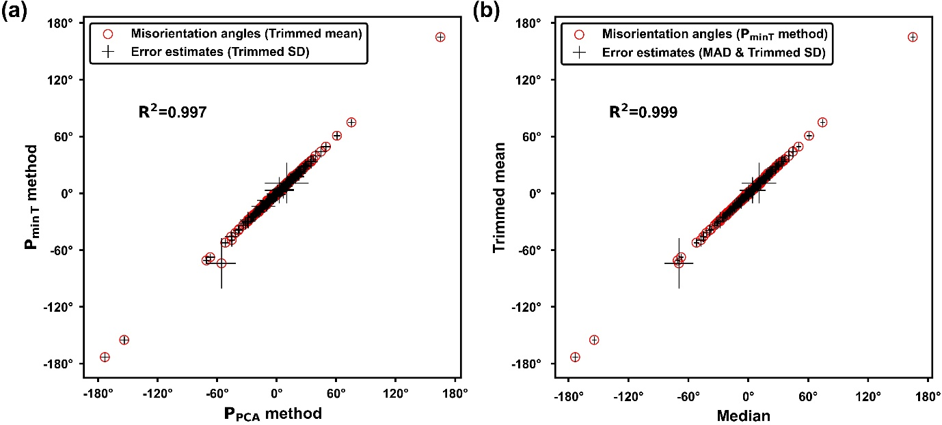

**Fig. S1.** (a)Comparison of trimmed mean estimates for each validation period from the *PPCA* and *P*min *T* methods. Red circles are estimated misorientations for each validation period. (b) Comparison of median and trimmed mean estimates calculated from the *P*min *T* method.

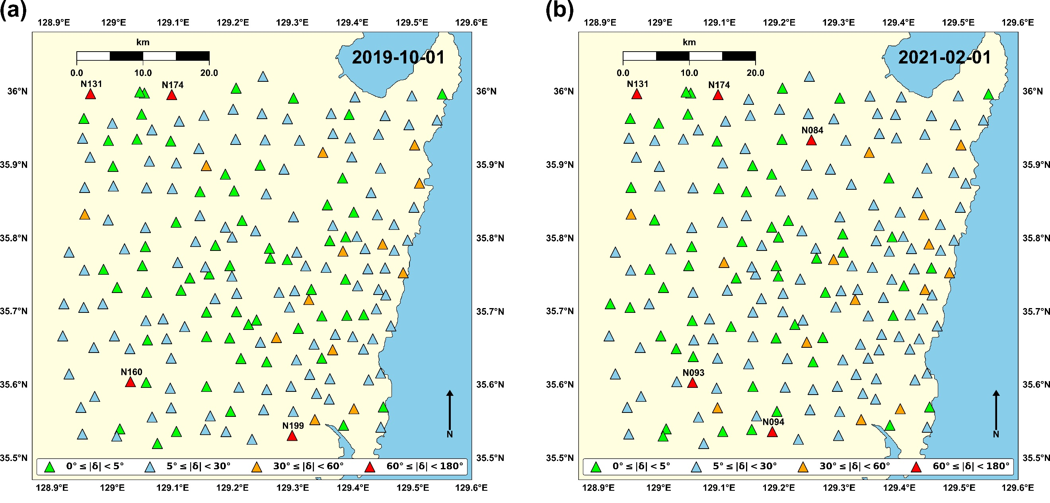

**Fig. S2.** Misorientation angles for GHBSN stations for two selected periods: (a) October 1st, 2019 and (b) February 1st, 2021. 191 and 197 stations whose data were available at each period are plotted in (a) and (b), respectively. Each station is colored based on the absolute value of misorientation angle (|δ|). The severely rotated (60° ≤ |δ| < 180°) stations are marked in red and annotated with their station names.

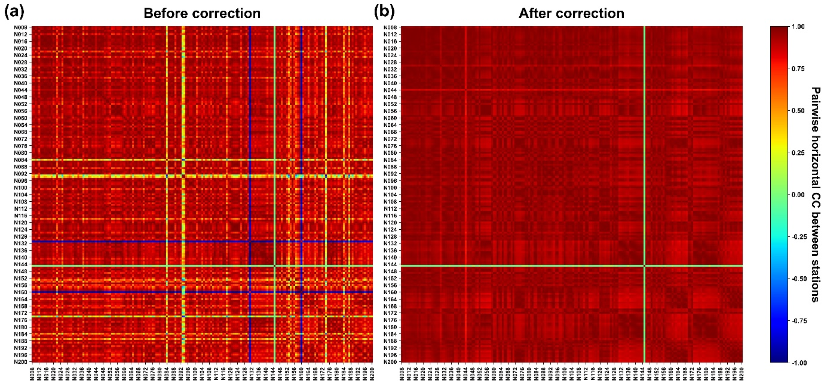

**Fig. S3.** Pairwise horizontal CC between 193 stations calculated (a) before misorientation correction and (b) after misorientation correction. Event 1 in Table 1 was used for CC calculation. The CCs of station N044 and N145 are still low after correction because of low SNR of horizontal seismograms.

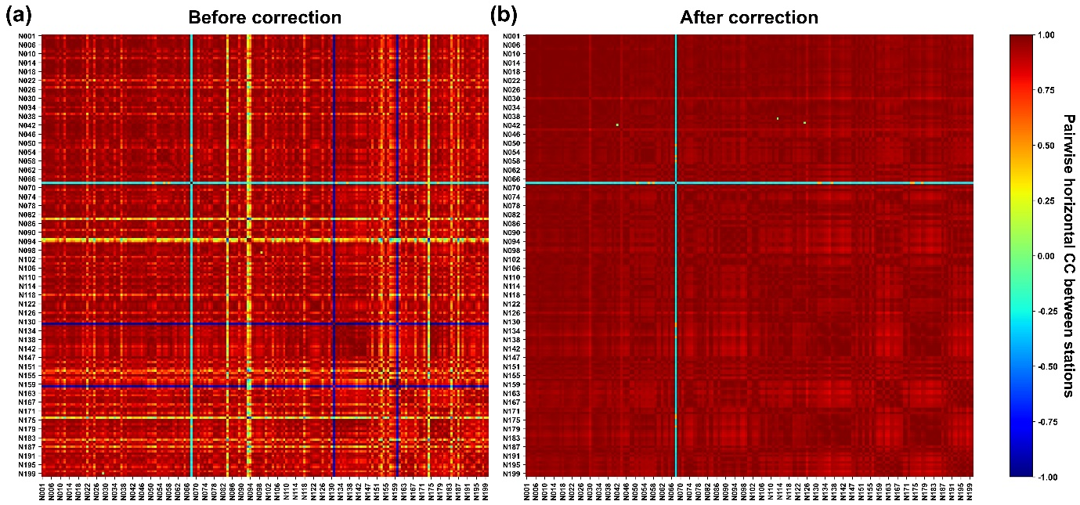

**Fig. S4.** Pairwise horizontal CC between 198 stations calculated (a) before misorientation correction and (b) after misorientation correction. Event 2 in Table 1 was used for CC calculation. The CC of station N068 is still low after correction because of low SNR of horizontal seismograms.

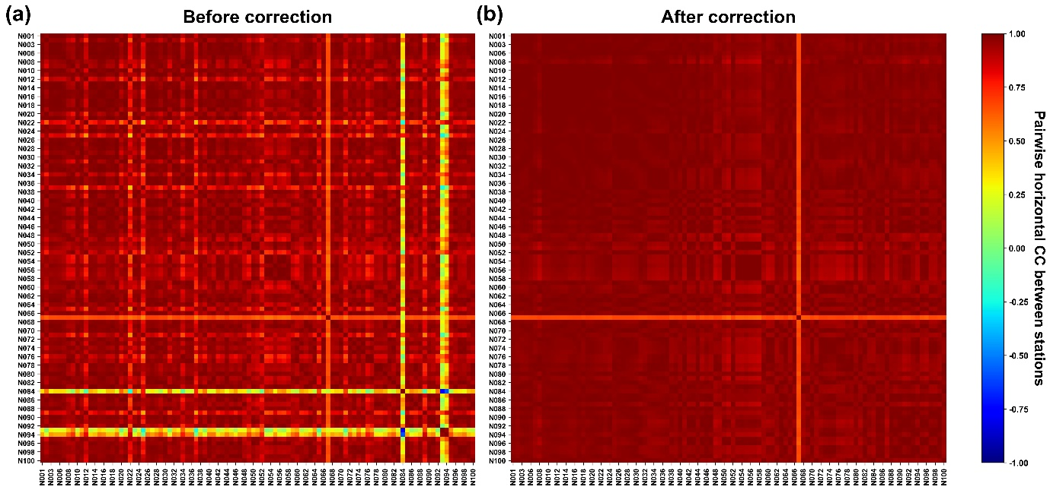

**Fig. S5.** Pairwise horizontal CC between 99 stations calculated (a) before misorientation correction and (b) after misorientation correction. Event 4 in Table 1 was used for CC calculation. The CC of station N067 is still low after correction because of low SNR of horizontal seismograms.

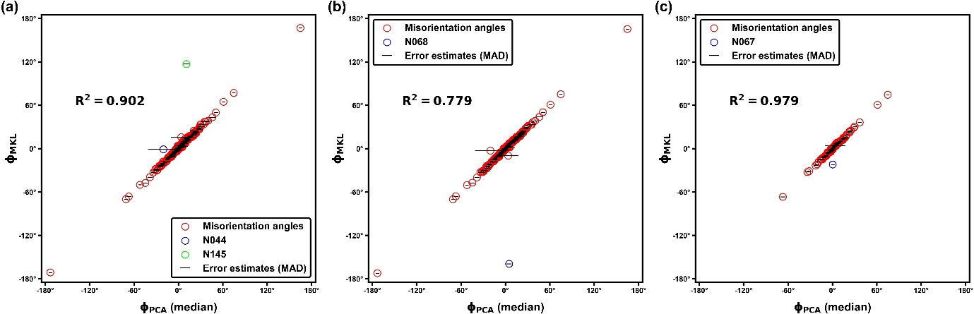

**Fig. S6.** Comparison of the median misorientation estimates from the *PPCA* method and the misorientation estimates from the correlation–based method applied with MKL station of KG network (Figure 1) and for (a) event 1, (b) event 2, and (c) event 3 (Table 1). In panel (a), stations N044 and N145 marked by blue and green empty circles, in panel (b), station N068 marked by blue empty circle, and in panel (c), station N067 marked by blue empty circle deviate from the linear trend. These 4 stations which deviate from linear trend are all characterized by low horizontal CC due to low SNR of horizontal seismograms. Except for these stations, correlation between estimates from two different methods are very high.

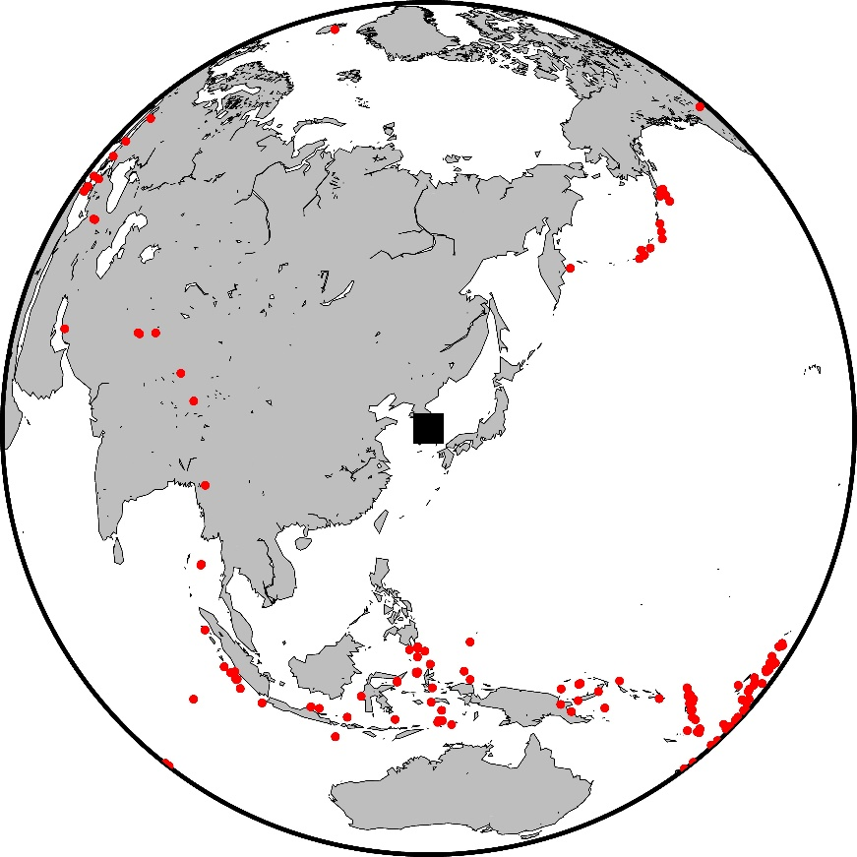

**Fig. S7.** The map showing 517 teleseismic earthquakes for the receiver function (RF) analysis. Each event is marked as a red dot. Black square marks the reference location of 36.5 °N, 128 °E.

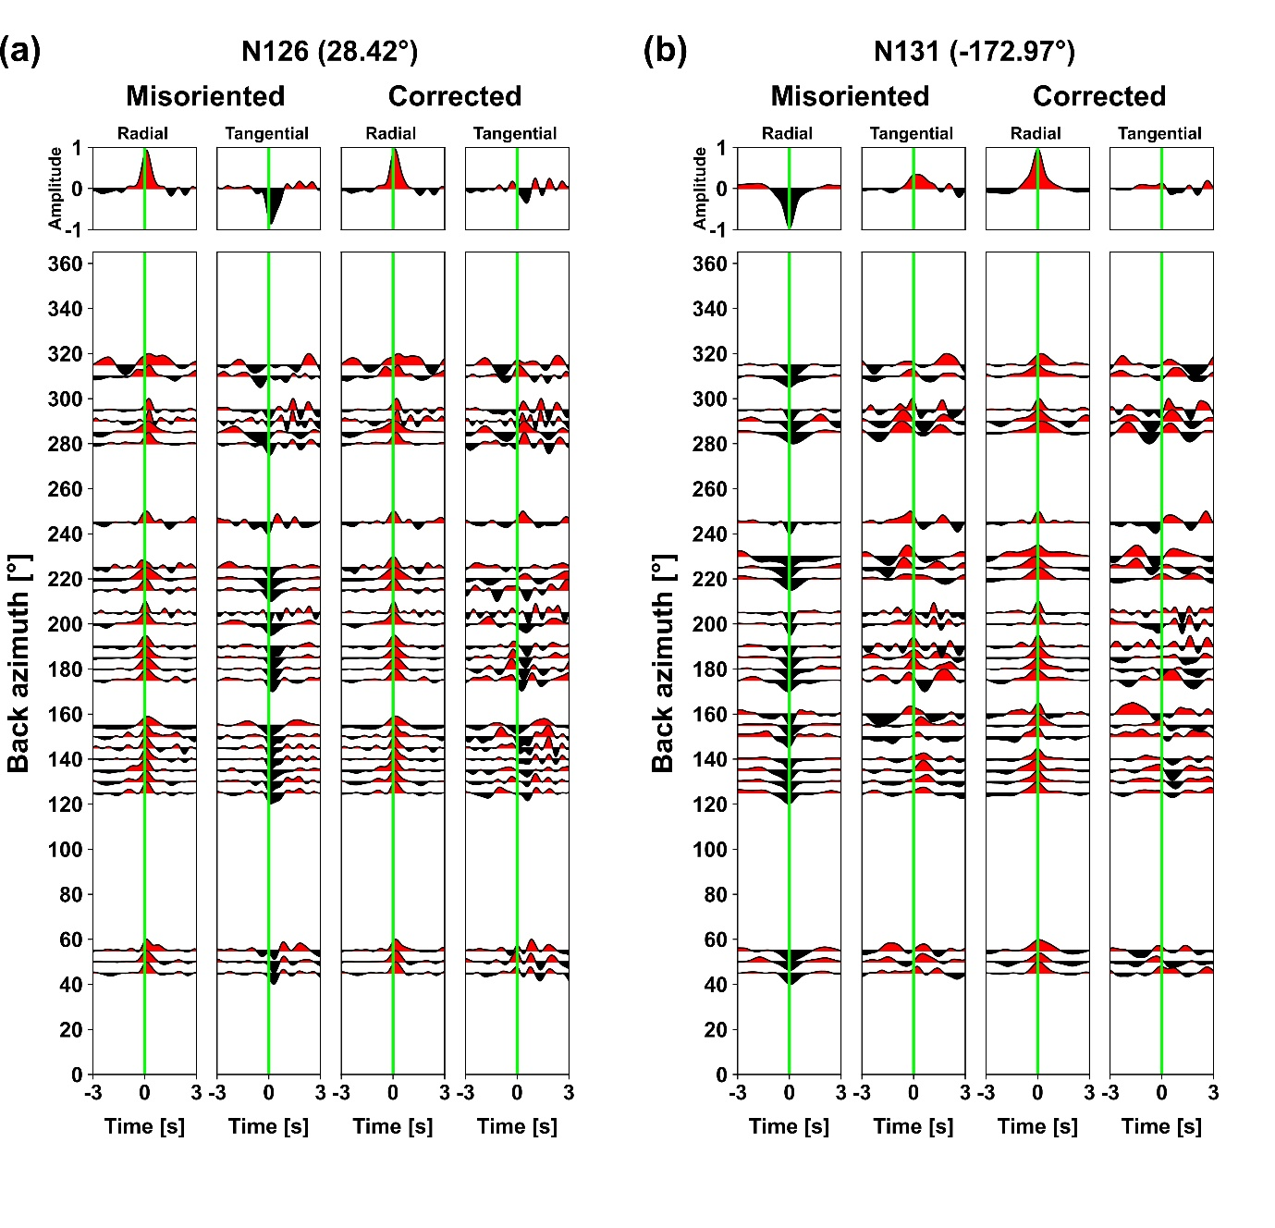

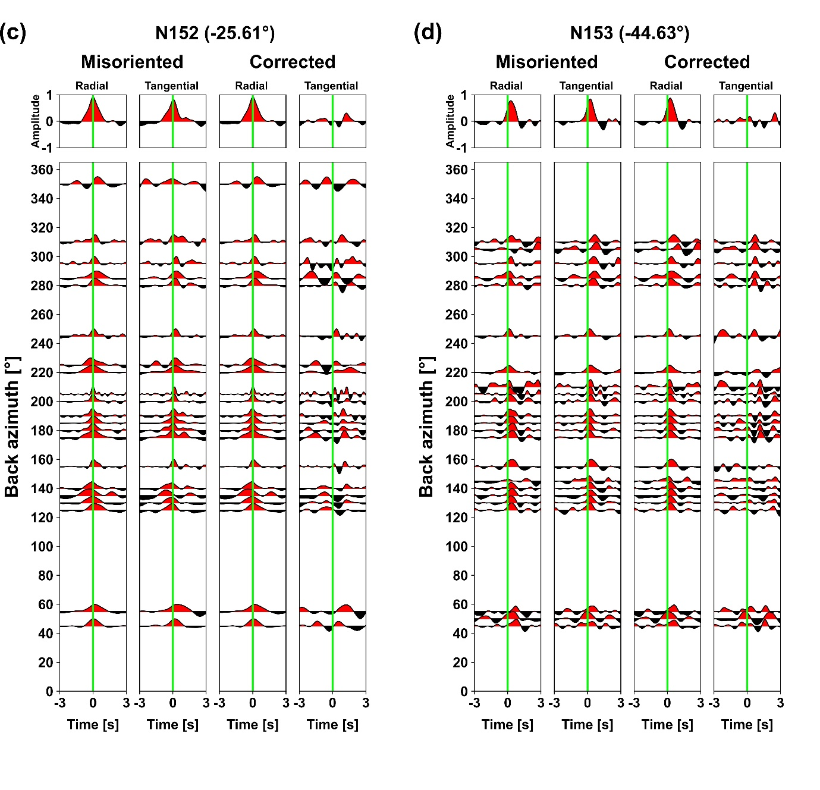

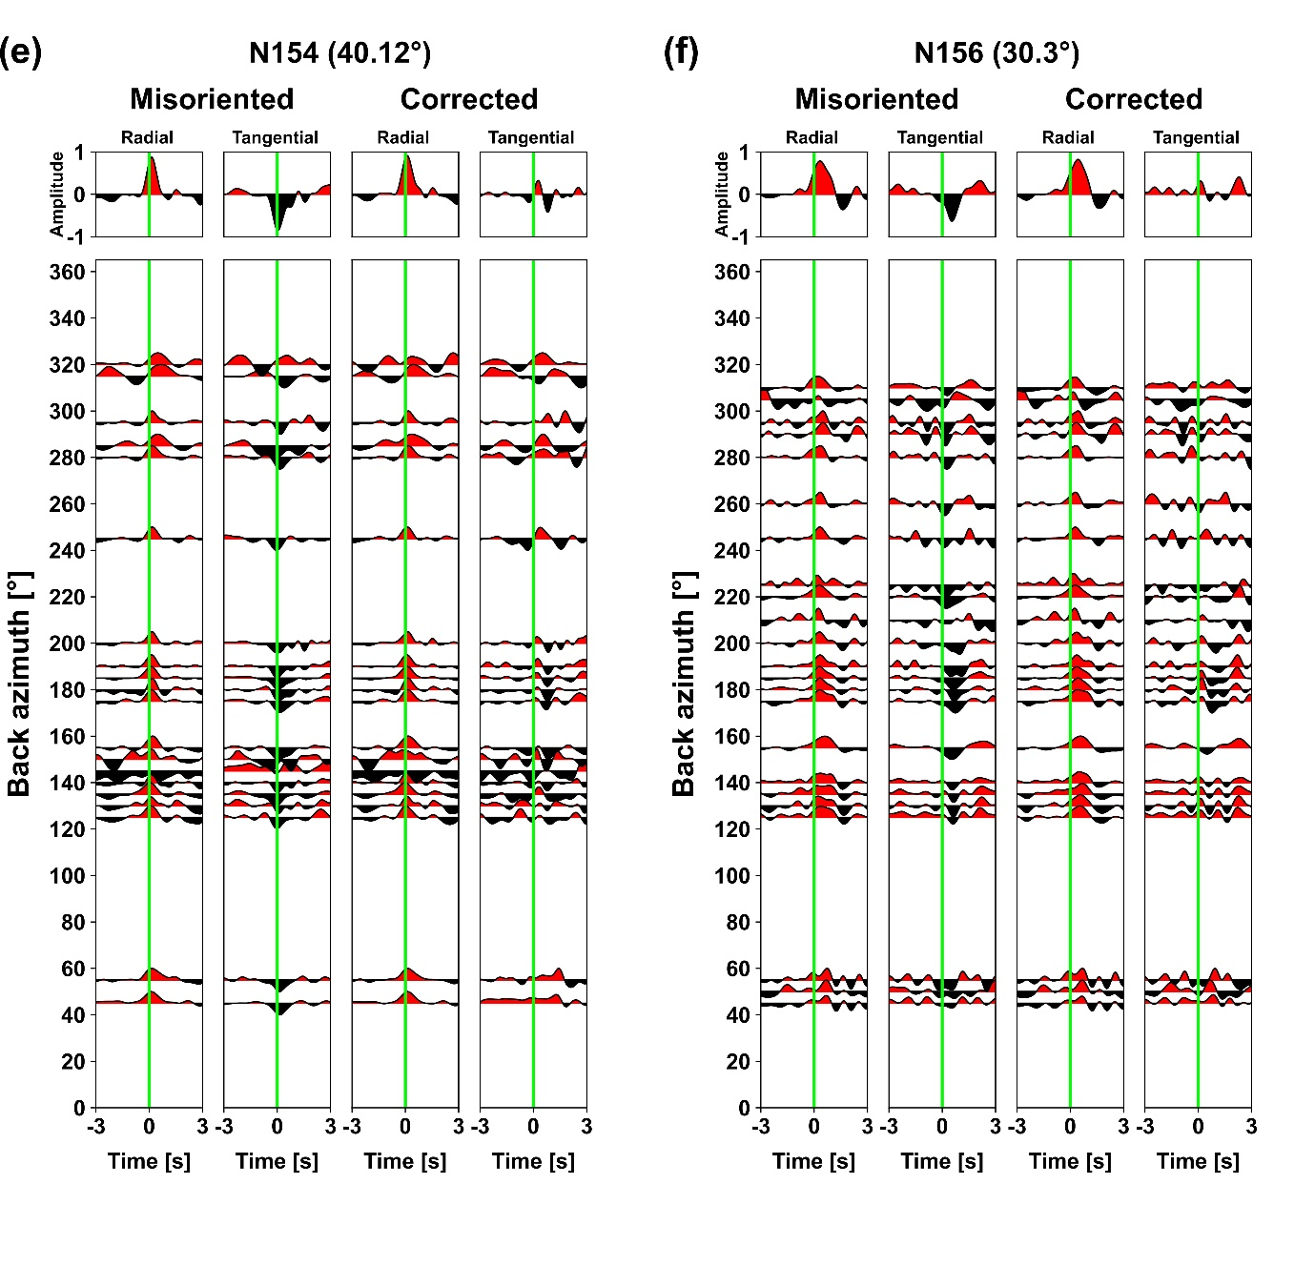

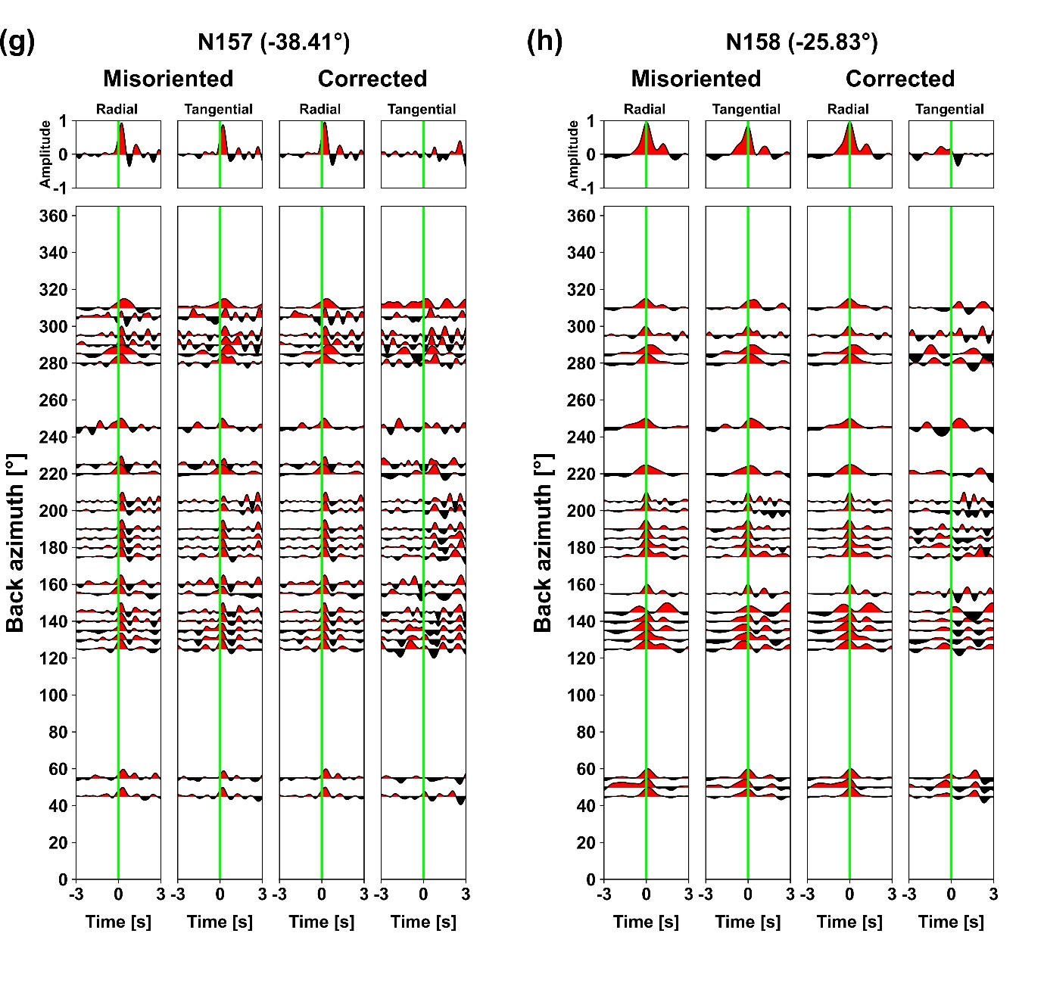

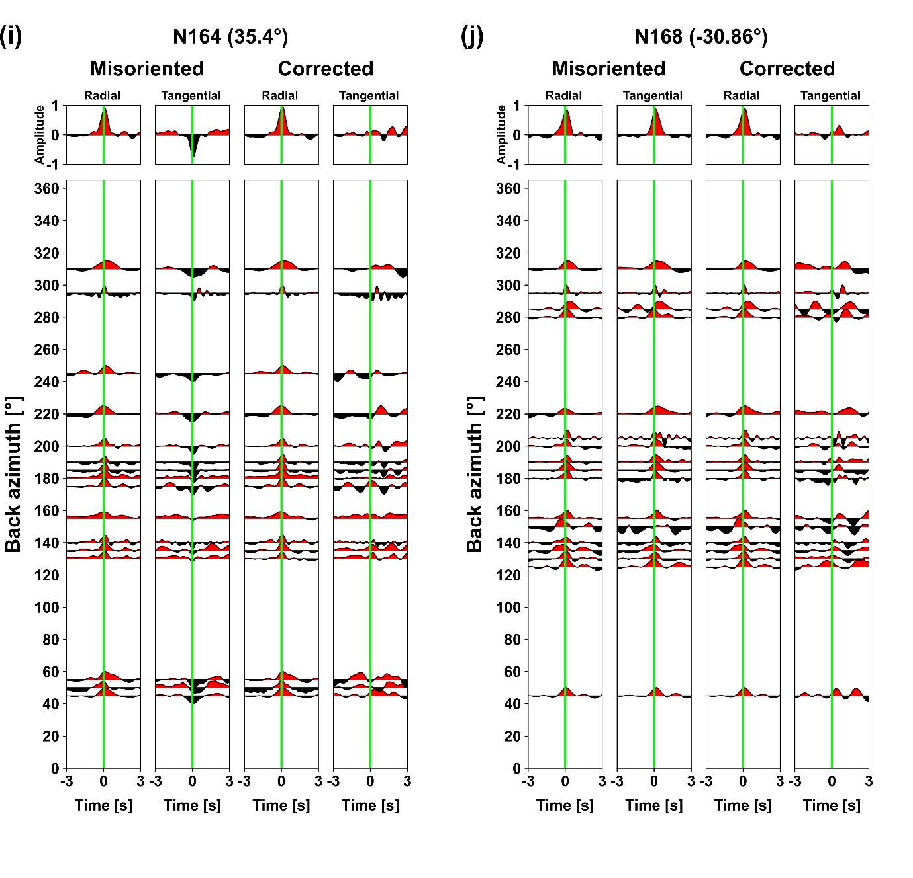

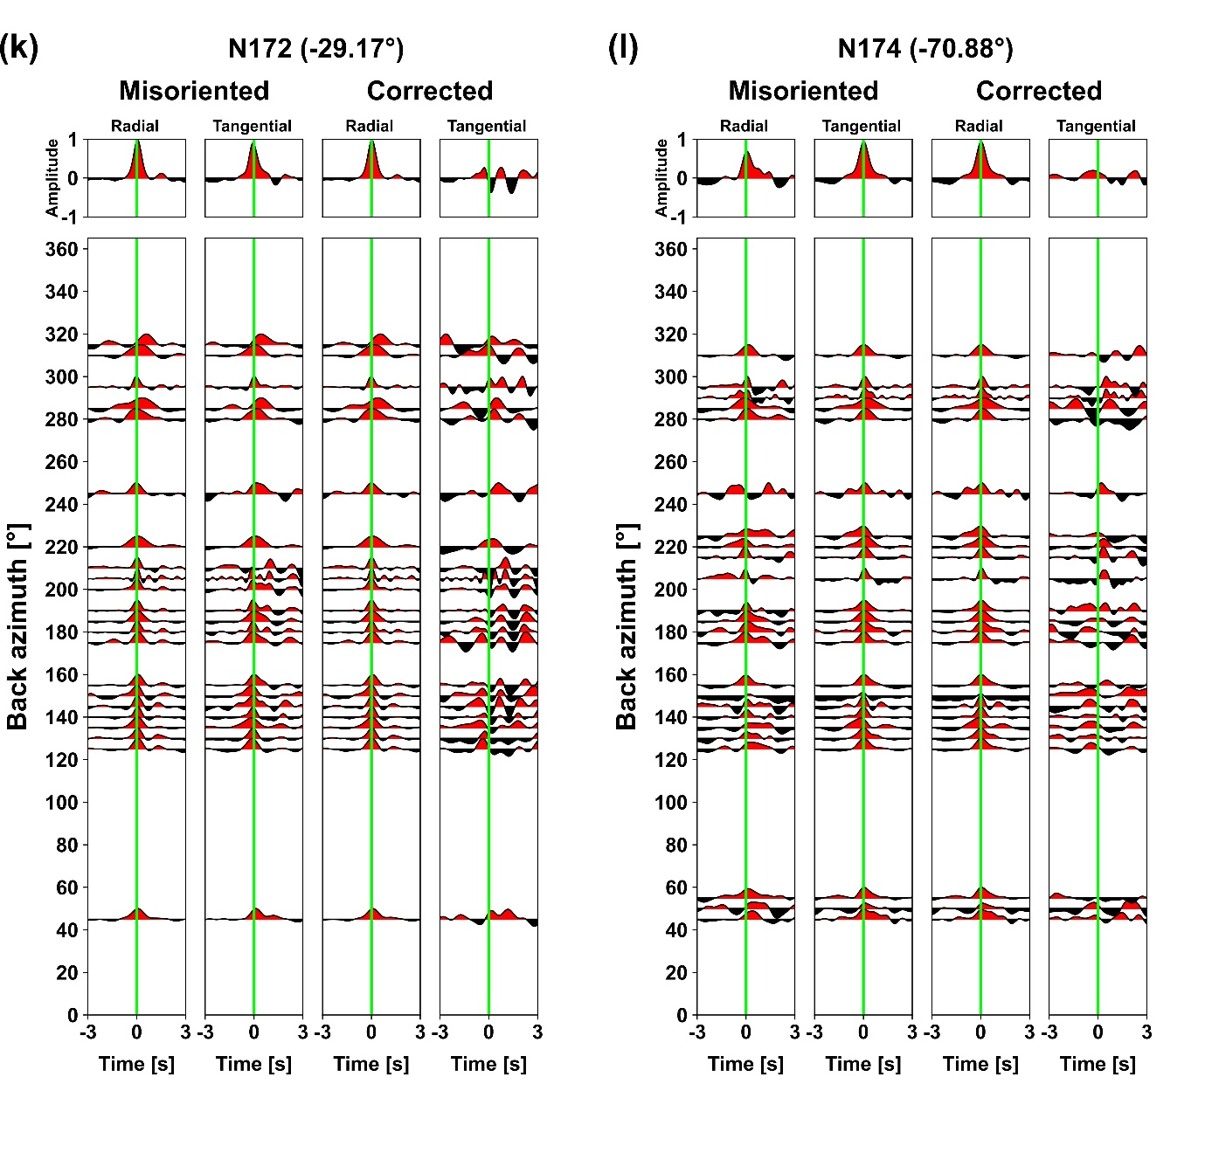

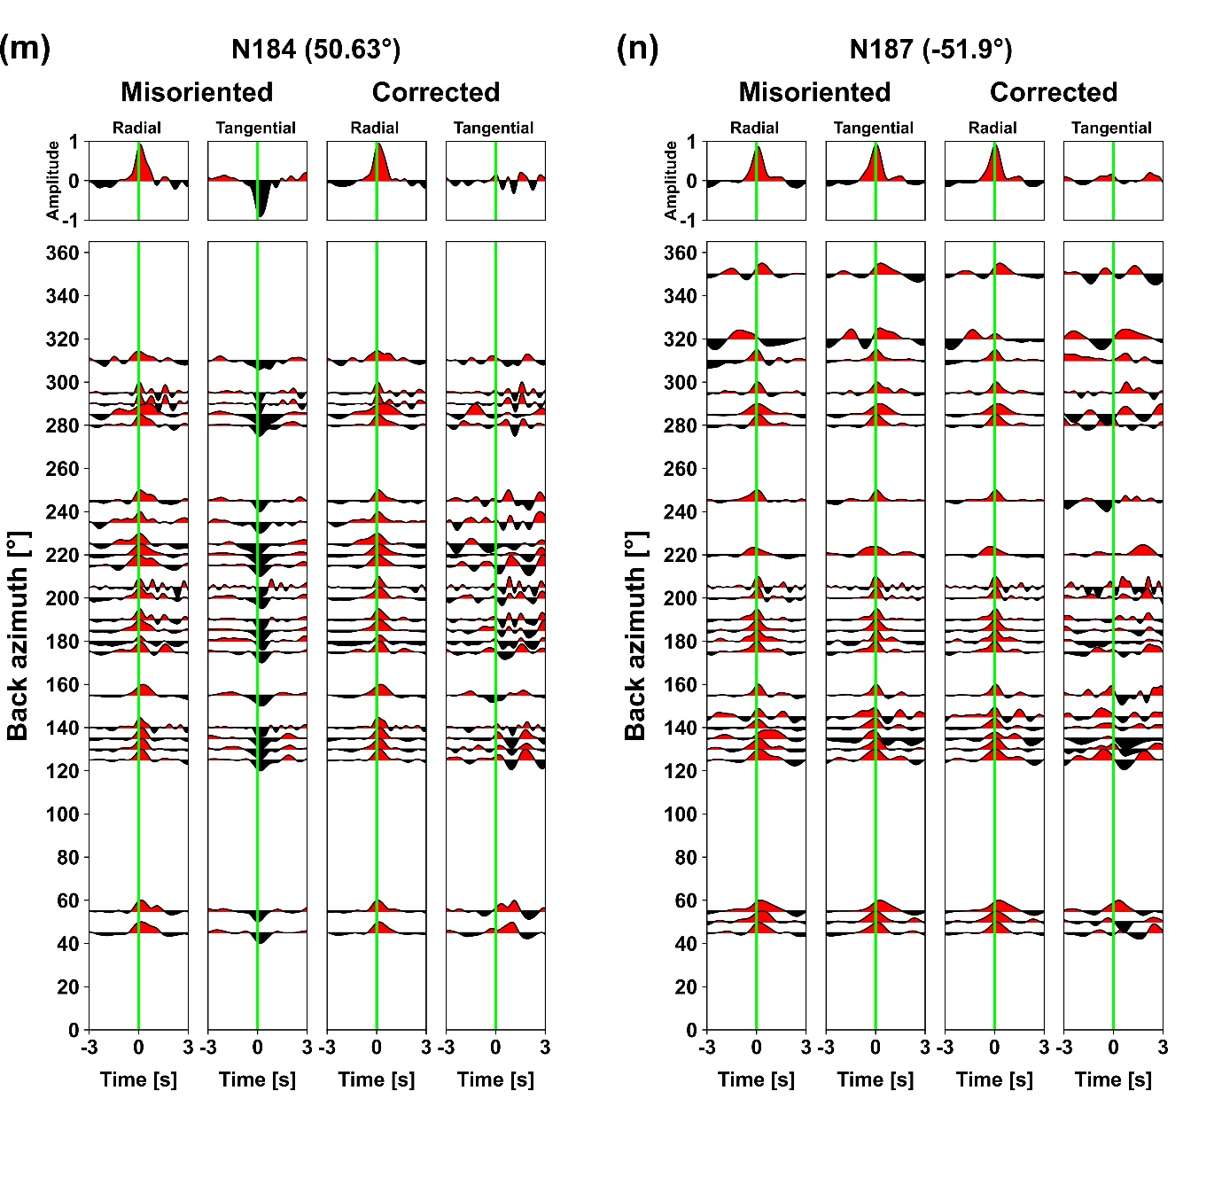

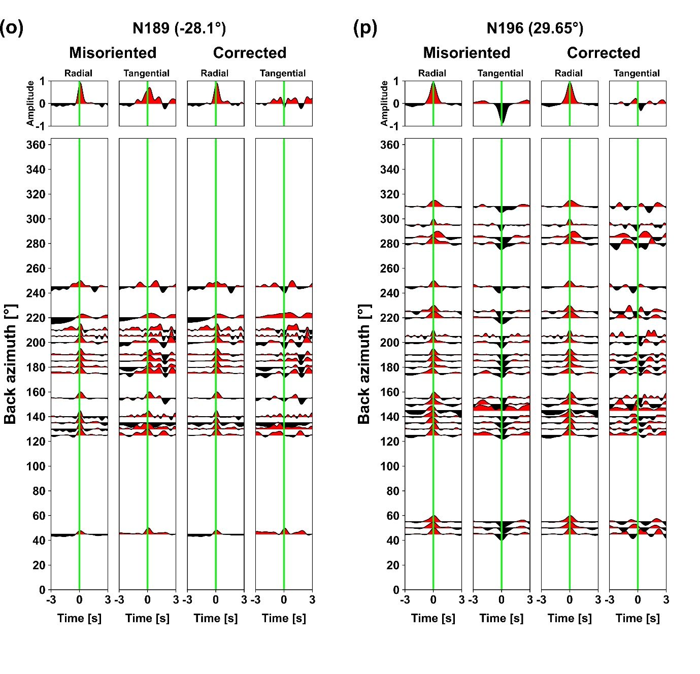

**Fig. S8.** The back­–azimuthal record section plots of R–RFs and T–RFs before and after correcting for misorientation ((a)–(p)) for the 16 stations. The stacked traces displayed at the top are the same as ones shown in Figure 10. Misorientation angle corresponding to each station is annotated inside the parentheses beside the station name. Calculated RFs were normalized and stacked over 5° interval. Green vertical lines mark 0 s. All analyzed record sections show that the amplitude level of T–RFs at/near 0 s is substantially decreased after the correction.